**Phenom project**

Software functionality changes

Version A.3

30 May 2023

**Table of content**

Glossary 2

Introduction 3

Purpose 3

Scope of the project 3

References - Design 5

System Features 8

Splash 9

Login 9

Registration process 12

Reset password 14

Instruction 17

Home screen 17

Main menu 17

New event 19

Event 21

Triangulation 34

Story 38

Events 41

Recent Events 41

My events 45

Teammates events 47

Event details 48

Debrief 52

Chats 52

Channels 53

Chat list 57

Create a chat 59

Search chat 62

Chat screen 64

Chat attributes 65

Message 66

Mentions 67

Links 67

File upload 68

Upload Photo 69

Upload video 71

Upload Document 73

Unavailable files 74

Group chat settings 75

Editing information and photos 75

Invite User 77

Delete User 78

Leave the chat 79

Profile 79

Teammates 81

My Team (Team Creator) teammates management 81

Creator can search and add teammates 81

My Team. List of teammates 83

Requests to join my team 88

Notification 89

User (requestor) can search the team and ask to join 90

Searching and requesting 90

Requestor can monitor the status of the request 90

Requestor can cancel the request 90

Notification 91

Team mate profile 91

Settings 92

Advertisement 94

Deployment 95

Reporting a profile 98

Reporting a User (Content) instruction 100

Blocking Events (from Admin console) 100

Blocking User (from Admin console) 103

Update of the Phenom app 108

Android 108

IOS 109

Enumerations 109

Event = event 109

Event = story 110

Enum explanations (Info): 110

Event type 110

Observables 111

# **Glossary**

Teammates - the registered User

Triangulation - is the process of determining the location of a point by forming triangles to it from known points.

Azimuth - is an angular measurement in a spherical coordinate system. The vector from an observer (origin) to the point of interest is projected perpendicularly onto a reference plane; the angle between the projected vector and a reference vector on the reference plane is called the azimuth.

The elevation angle is a vertical tilt of your device.

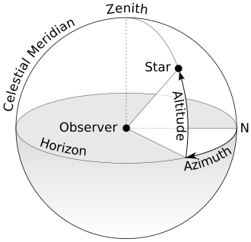

# **Introduction**

## Purpose

The SRS is intended for all members of the development process. It describes all the functionality which needs to be developed, in particular:

* Android mobile client;
* Firebase triangulation function

The Android mobile app will be developed for users (any people interested in capturing the event via the app. The User can calculate the location of any observed stable object (phenomenon/event) with the help of the triangulation method. The users have the opportunity to make an event and remove it, review the other User's event and triangulate it, review his or his teammate's event on an integrated Google maps. Communicate with each other using messages and see what the most recent events have been created worldwide.

## Scope of the project

* + Phenom includes the following parts:
* Server-side - Firebase based;
* Android application;
* IOS application;
* Pub Nub side – Chats.
* Android Mobile Client:

The mobile application is intended for any user who wants to capture the event, identify the not the exact position, only approximate one of the events with the help of the triangulation functionality, and notify another user about it.

* IOS Mobile Client:

The mobile application is intended for any user who wants to capture the event, identify the not the exact position, only approximate one of the events with the help of the triangulation functionality, and notify another user about it.

* Back end functionality:

Performs functions related to all application logic, as well as triangulation. The triangulation functionality is done on the back-end side. The next steps will follow the calculation of the triangulation functionality:

* Transfer latitude and longitude to cartesian coordinates
* For each User, we construct the equations of the line
* Looking for intersection points between all pairs of lines
* Find the average of all intersection points
* Pub Nub side

Integration with Pub Nub allows you to store the entire correspondence history between users, manage user chats, etc.

## References - Design

|  |  |
| --- | --- |
| Title | URL |
| Android app | <https://www.figma.com/file/gikqaZc2SC3HYFbxeqIwm5/Phenom-Ui-Set?node-id=983%3A2> |
| IOS app | <https://www.figma.com/file/gikqaZc2SC3HYFbxeqIwm5/Phenom-Ui-Set?node-id=4339%3A226> |

**Compatibility**

The development team will ensure mobile app compatibility only with the following devices, OS Versions, and Resolutions:

1. Mobile device application
2. Android application
3. Devices:
4. Samsung Galaxy S5 (SM-G900F)
5. Samsung Galaxy S6 (G920F)
6. Samsung Galaxy Note 4
7. LG X Style
8. Nexus 6P
9. Xiaomi MiA1
10. Nexus 7
11. Nexus 9
12. OS Version:
13. Android 7
14. Android 8
15. Android 9
16. Resolutions:
17. 1920x1080
18. 2560x1440
19. 1920x1200
20. 2048x1536
21. IOS application
22. Devices:
23. iPhone 7
24. iPhone 8
25. iPhone X
26. iPhone XR
27. iPhone 11
28. OS Version:
29. IOS 15
30. IOS 16
31. Resolutions:
32. 1334x750
33. 2436x1125
34. 1792x828

Mobile applications:

1. The Android Phone application will be tested on devices: Samsung Galaxy S5 (SM-G900F), Samsung Galaxy S6 (G920F), Samsung Galaxy Note 4; LG X Style, Nexus 6P; Xiaomi MiA1, Nexus 7, Nexus 9.
2. The iOS application will be tested on devices: iPhone 7; iPhone 8; iPhone X, iPhone XR, iPhone 11.

*This mobile application will be developed for both portrait and landscape modes.*

**Overall Description**

The Phenom is an application that can be downloaded from the Marketplace (if the Client provides us with all required assets. The application allows users to register with the Auth firebase flow and become teammates. Then the User appears on the teammates' list screen.

The application intends to capture the stable event and calculate the exact position. While capturing the photo, a 30-sec video with other metadata required for the triangulation functionality is mad. The event creator cannotchange the media info such as user location, bearing, elevation angle, and time is taken.

After the User-posted the event, the other users are notified. The posted event is available on the home screen and shown in a collapsed view but can be explored while pressing on the "see more. In addition, the users can see the event on the map. The map has the User's ID marker and shows where the User is looking while doing the shot.

After the User posted the event they can provide more details on the event by adding a debrief for the existing event. Debrief allows to attach a video where user describes details of the event. When an existing event is attached with a debrief then all users get notified so that they can see.

The User's event can be triangulated while pressing the triangulation button, and the camera screen opens. So, the User who sees the same event can capture it but can review the captured result but can't change the event. As a result, captured photo of the event is automatically posted.

Any user can add their data to the event, and we'll triangulate it again. The more data we have, the more precision we get.

The users can also exchange messages with each other. In addition, the chat functionality allows you to exchange media files, create groups, and private chats.

The users can see which three latest events were created inside the application.

Application allows to register events happened in the past using Epic Function feature. For this purpose User can record a video and verbally describe the Story. When that record type (type=story) is added into the system then all other users get notified about new event and can see the Storys This feature is interesting to the owner of the app so that Owner can reach out the user and speak to them. To allow incoming contacts User must set the specific flag in the profile: ‘Allow Phenom to contact me’.

# **System Features**

## Splash

The splash screen includes the following elements (Figure 3.1):

* company name;
* app name;

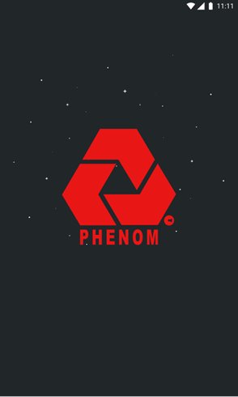

Figure 3.1 - Splash screen

## Login

The mobile User will see the login screen when he isn't logged in when he opens the app. The User needs to be registered or logged in to the app to use the available app functionality. (Figure 3.2)

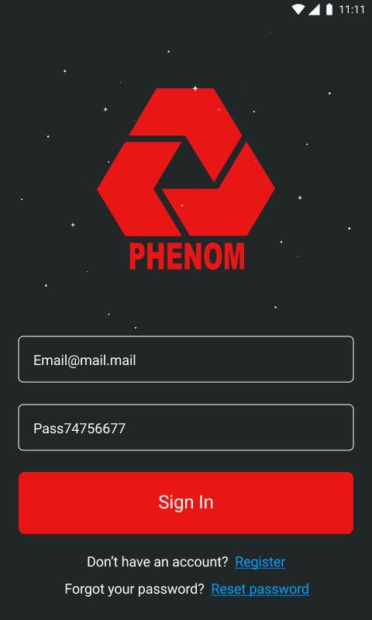

Figure 3.2 – Sign in

|  |  |  |  |  |
| --- | --- | --- | --- | --- |
| **Field Name** | **Field Type** | **Required** | **Accepted Values** | **Field Length** |
| Email | Email | Yes | Validation: email regex | Min Length: 3 characters  Max Length:255 characters |
| Password | Password | Yes | RequireDigit = true;  RequireSymbol = true; [ !@#$%^&. ]  RequireUppercase = true  RequireLowercase = true; | Min Length: 8 characters  Max Length:64 characters |

As for the login and authentication will be used Firebase. Firebase authentication is used to authenticate the users of applications very easily.

To authenticate User will need to fill in the authentication credential. These credentials will be an email password. Password can contain letters, numbers, and ".","_" symbols. After passing the credentials, Firebase will verify the credentials, and in return, the User will get a response that tells him if the authentication is successful or not.

The flow of the login and register using Email and Password with the help of Firebase presents in Figure 3.2.1.

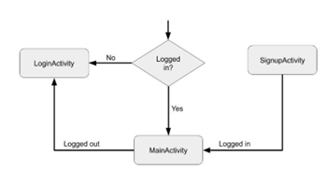

Figure 3.3.1- Firebase authentication in the application

**Main Activity**: This is the main activity of the application. The User will be redirected to this activity if the User is successfully logged in or has created a new account.

**Login Activity**: This activity is used for logging in the User into the application and, after successful login, transfer the User to Main Activity. It contains two text fields for taking email and password from the Use. Two buttons for Login and Sign up (Sign up button will transfer the User to the Sign-up Activity).

**Sign up Activity**: This activity is used to register the User into the application and, after successful registration, transfer the User to the Main Activity. It contains two text fields for taking email and password from the User for registration. Two buttons for Sign up and log in (login button will transfer the User to the Login Activity).

## Registration process

A user can register in the app. The registration process includes the following steps:

1. to fill out a registration form, which includes the following fields (Figure 3.3):  
    . First name;  
    . Last name;  
    . Email;  
    . Password;  
    . Confirm Password.

The User can go back to the login flow by selecting the "Sign in" button, so the screen (Figure 3.2) is opened.

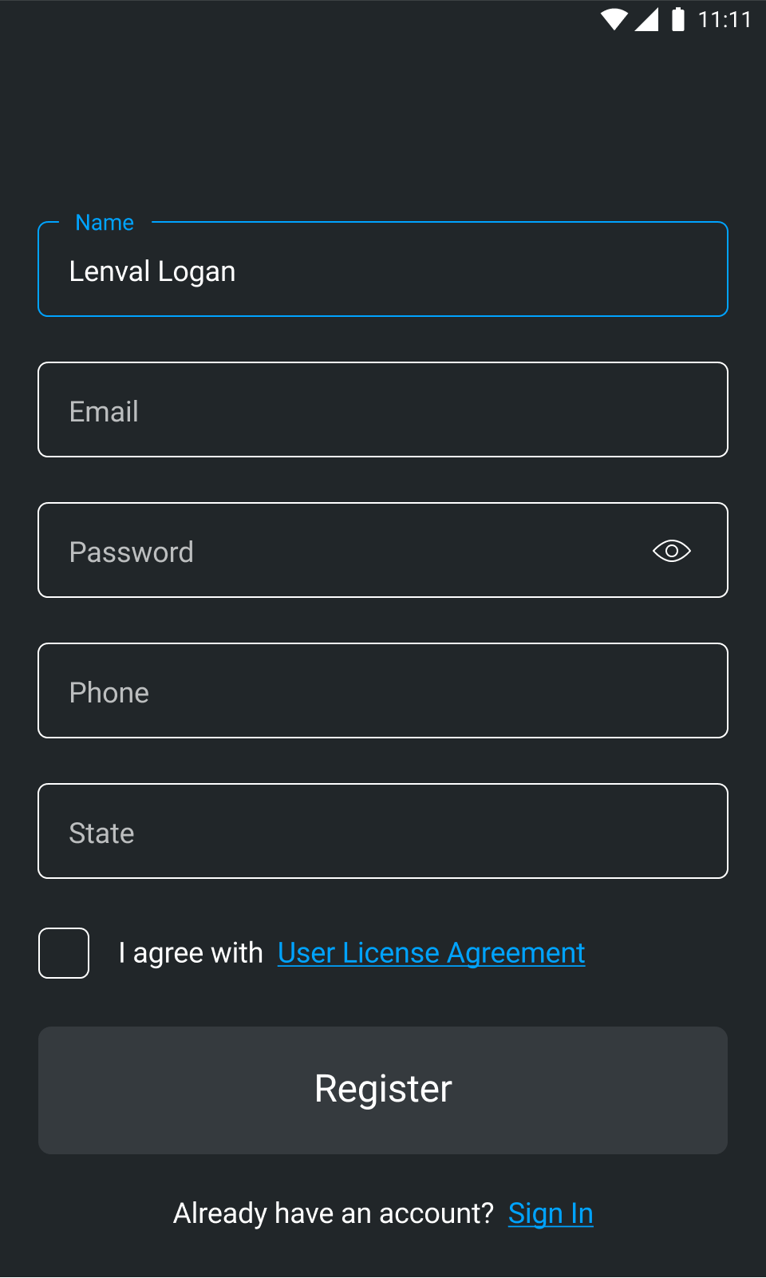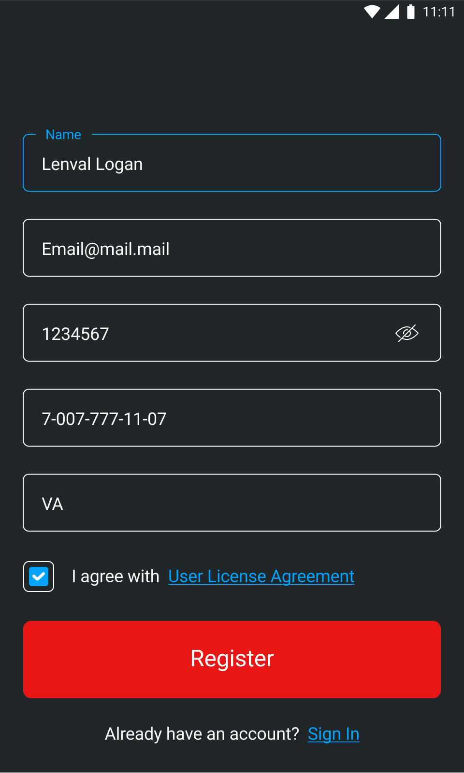

Figure 3.3 - Sign up

|  |  |  |  |  |
| --- | --- | --- | --- | --- |
| Field Name | Field Type | Required | Accepted Values | Field Length |
| Name | Input Field | Yes | Validation: only characters and digits. | Min Length: 3 characters  Max Length:255 characters |
| Email | Email | Yes | Validation: email regex | Min Length: 3 characters  Max Length:255 characters |
| Password | Password | Yes | RequireDigit = true;  RequireSymbol = true; [ !@#$%^&. ]  RequireUppercase = true  RequireLowercase = true; | Min Length: 8 characters  Max Length:64 characters |
| Phone | Input Field | Yes | No Validation; | Min Length: 1 character |
| CheckBox | CheckBox | Yes | - | - |
| States or Country Code | Input Field | Yes | Validation: only characters; | Length:2 characters |

## Reset password

If a user forgets his password, he can click the link "Reset password" on the login screen:

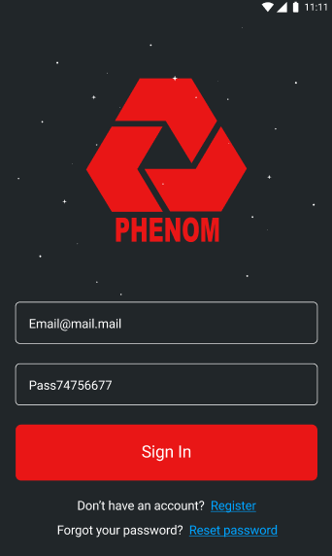

Figure 3.4 Forgot your password?

A user is redirected to the screen "Enter your email." Then, the phenom app will check if the entered email is valid and exists in the system:

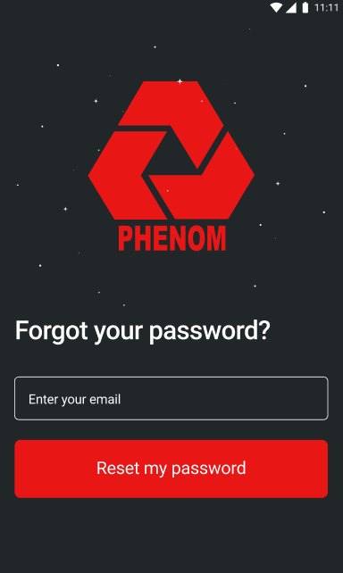

Figure 3.4.1. - Enter your email

A user gets an email with a new password if the email is valid. This functionality is implemented using Firebase tools.

A user can see a standard confirmation message:

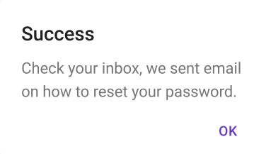

Figure 3.4.2. - Confirmation message

If a user enters not a valid email, he gets an error message:

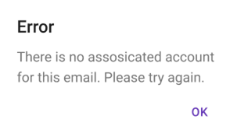

Figure 2 . Error message

## Instruction

When a new user logs in for the first time, the system presents him with the main features that are in the application.

The User sees a carousel of screenshots with a description.

## Home screen

The home screen of the application is the My events screen (3.10. This screen should be displayed by default when loading the application.

## Main menu

For the convenience of switching between system parts, the interface should contain a tab bar with buttons, which provides quick access to the system's main features.

The tab bar should contain:

* Button for creating a new event
  + To add new event
  + To add new story
* Button for switching to Home screen
  + Home screen=My Events (list of events created by the owner of the profile)
* Button for switching to chats
* Button for switching to Profile
* Button for switching to Recent Events

The system should highlight the icon that was pressed to open a certain part of the system.

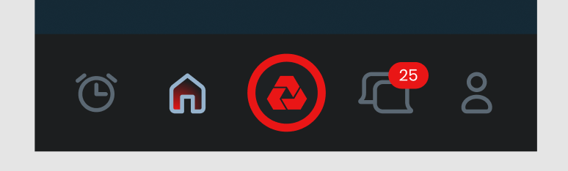

Figure 3.7. - Tab bar

If the no event were created, then above button for creating event appears a small pop-up "Press to create new phenom".

The logic:

- The pop-up should appear when a user just launch the app and be visible for 5 sec;

- The pop-up should appear each time when a user launches the app;

- If a user continues to use the app, the pop-up shouldn't appear repeatedly.

# New event

When creating a new event then User myst specify what type of event is going to be created:

* event
* story

The bottom of the screen has the "Add" button. If the User presses on the "Add" button, the initiation process starts for capturing the static event (by default).

Here User has a choice:

1. Continue with the default flow (registering an Event that is currently happening)
2. Switch to create a Story (tell a story about event happened in the past)

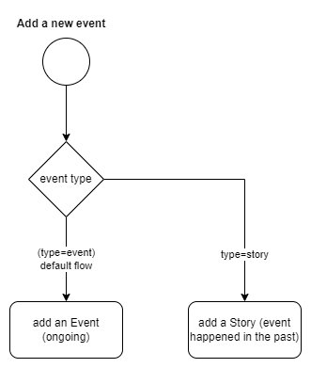

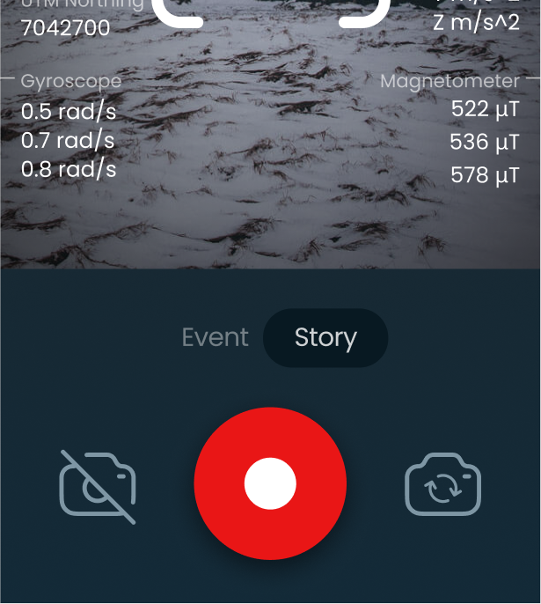

## Event

When User selected to register an ongoing event the camera screen is opened (see above) User must press the capture photo button to capture the ongoing event.

User can

* Start registering the event (recording)
* See HUD information (sensors)
* Stop recording
* Retake the video
* Go next to complete the form

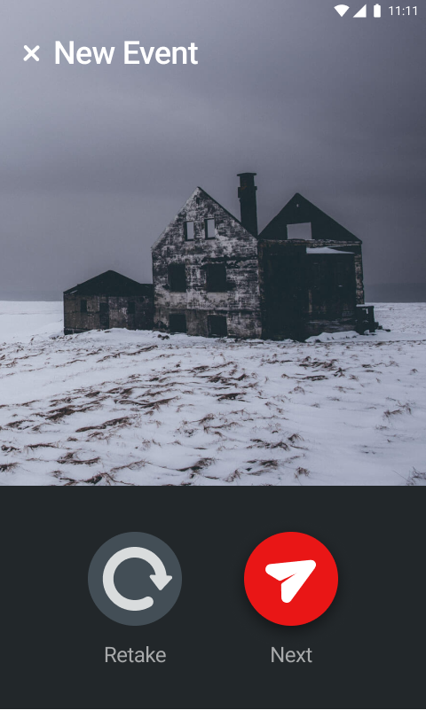

Retake/Next

Adding details of the vent’s details – GUI

The User can see the capture details page with the next parameters (Figure 3.8.3):

1. **Captured image with 30sec video;**
2. **Event type**
3. **Observables(Provided that "UAP / UFO" has been selected)**
4. **Short event description;**
5. **Bearing, which measured in degrees**
6. **Elevation angle, which is measured in degrees**.   
   Note that an elevation angle is only shown on UI and is not a part of the triangulation.
7. **Local Time;**   
   DTG stands for Date/Time Group in a 24-hour clock format:   
   DD:MM: YYYY, HH:MM: SS;   
   Example - 4 February 2022, 21:00:00L
8. **GMT Time;**   
   Example - 4 February 2022, 21:00:00Z
9. **Latitude;**   
   Latitude is an angle (defined below) which ranges from 0° at the [Equator](https://en.wikipedia.org/wiki/Equator) to 90° (North or South) at the poles.  
   Example - 15°24'15"N  
   <https://www.wikihow.com/Write-Latitude-and-Longitude>  
   Clickable. If user clicks on the latitude value, the system takes latitude and longitude values and redirects user to the map screen.
10. **Longitude;**   
    Example - 30°10'3"E  
    <https://ncert.nic.in/textbook/pdf/kegy303.pdf>  
    Clickable. If user clicks on the latitude value, the system takes latitude and longitude values and redirects user to the map screen.
11. **Altimeter**  
    Example – 26 m;
12. **Gyroscope**  
    Example – 0.5 rad/s.
13. **Magnetometer**  
    Example - 51 μT, 51 μT, 51 μT
14. **Accelerometer**  
    Example - X m/s2, Y m/s^2, Z m/s^2
15. **Pressure**  
    Example – 966 hPa
16. **UTM Easting;**   
    Example – 510500;  
    Doing the UTM's, please make sure the Zone number is displayed. See the example where the 10S is displayed in the image below.
17. **UTM Northing**  
    Example – 510500;  
    Doing the UTM's, please make sure the Zone number is displayed. See the example where the 10S is displayed in the image below.

All the data is collected during the event creation. The data is displayed on the user’s screen and changes during the video. The data is saved when the user clicks the button “Next”. Data collection can only be carried out if the phone has the necessary functionality. Furthermore, data collection can only be carried out if the phone has appropriate permissions allowed. Data collection will be done after phenom capture is started and required data is available.

The format in which data is shown - only 3 signs after ‘.’.

If some data is not shown, then the design changes - in place of the data that is missing, the other data that was below appears.

The logic of generating data and creating a triangulation does not change - the data that is stored by the event creator is always stored in the event details and does not change during the next triangulations.

When other users triangulate the event, they see data when creating a photo / video, however, this data is purely informational in nature and is not stored anywhere. (At the moment, the application has such logic, and we keep on it).

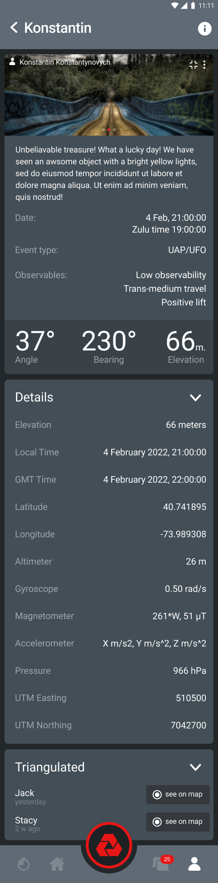 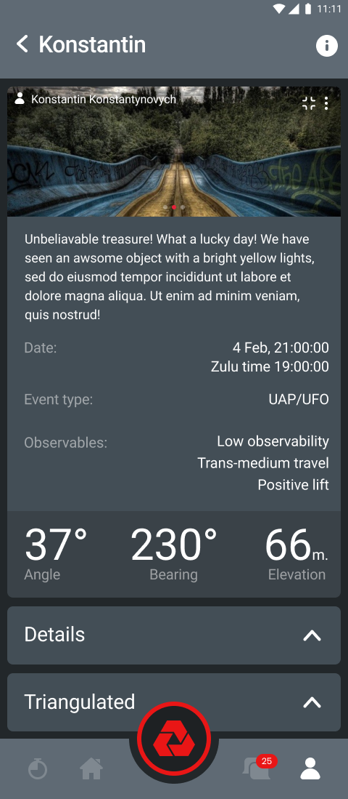

Figure 3.8.3 – Information

|  |  |  |  |  |
| --- | --- | --- | --- | --- |
| Field Name | Field Type | Required | Accepted Values | Field Length |
| Event Type | List | Yes | - | - |
| Description | Input Field | Yes |  | Max Length:300 characters |

Acceptance criteria:

* 1. The User can see the photo/video captured data before the event was posted.
  2. The User can add a short description (max 300 char);
  3. The User can add observables(Provided that "UAP / UFO" has been selected)
  4. The User can't change the location, bearing, elevation angle, and time and all the data that is collected during the event creation; A user can re-triangulate only, which, in turn, might cause changes in a position.
  5. If the User changes the photo, the metadata also changes;
  6. After pressing on the "Post" button, the event is shown in the background mode screen (Figure 3.8.8)

When User selected **UAP / UFO** then User can specify what they captured.

When the user clicks the "Add Observables" button, the User is taken to the Observables selection screen.

Choice options:

1. Sudden and instantaneous acceleration
2. Hypersonic velocities without signatures
3. Low observability
4. Trans-medium travel
5. Positive lift
6. Biological effects
7. Other

The User can choose several options. The system highlights the categories that are already selected.

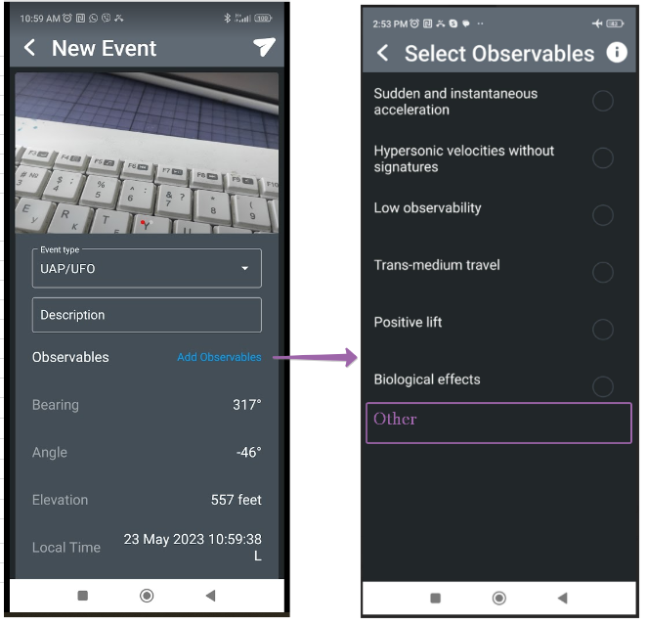

3.8.5. - Select observables

Also, the User can view information about what each of the stages means by clicking on the information button. (See Enumeration)

When you see these sixth observables all together, then we are forced to scratch our heads and conclude that maybe we don't know what these things are. We need more data and comprehensive research to do our best to understand what we are seeing.

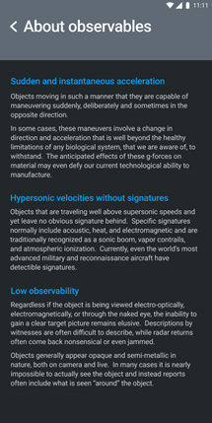

Figure 3.8.6. - About observables

When User selected **Paranormal** then User can specify what they captured (see Enumerations)

After the User has selected Observables, there can return to the previous screen and see the number of Observables they have selected.

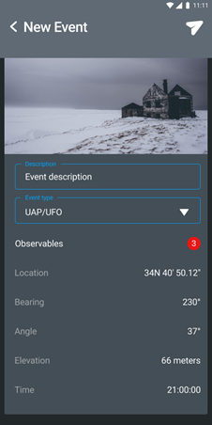

3.8.7. - After the User has selected Observables

The system adds observables to the event's information and their number and transfers them to the server-side (Firebase). Firebase User has added information about the event, the User can click on the download button, and the system will start the process of creating the even. If the User is not connected to a Wi-Fi network, the system must obtain permission to download data using the cellular network. (Figure 3.8.8.)

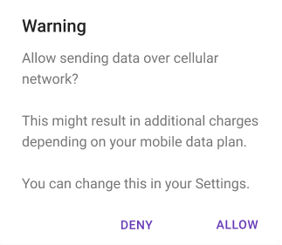

Figure 3.8.8. - Permission to use the cellular network

The system should notify the User of the download status.

Possible statuses:

1. We are uploading your event. It may take a few minutes. If you want to go forward and explore the app, click "Next" (Figure 3.8.9.)

2. We will upload your event when a Wi-Fi connection is established. (Figure 3.8.10.)

3. There is no internet connection right now. The event will be uploaded later when the internet connection is established. (Figure 3.8.11.)

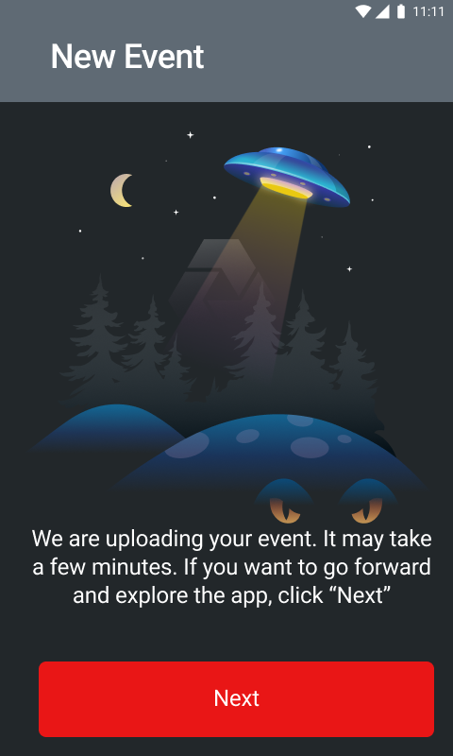

Figure 3.8.9.

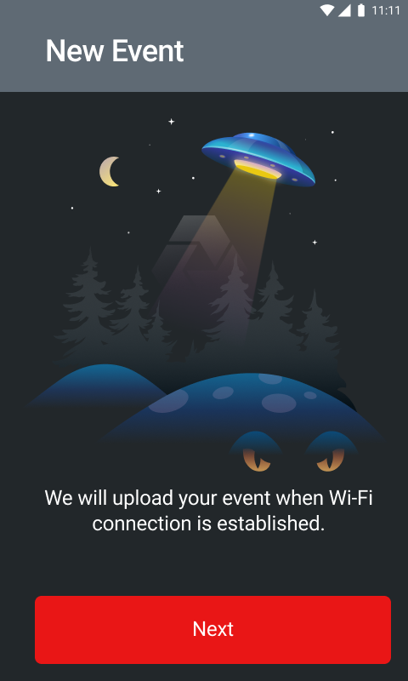

Figure 3.8.10.

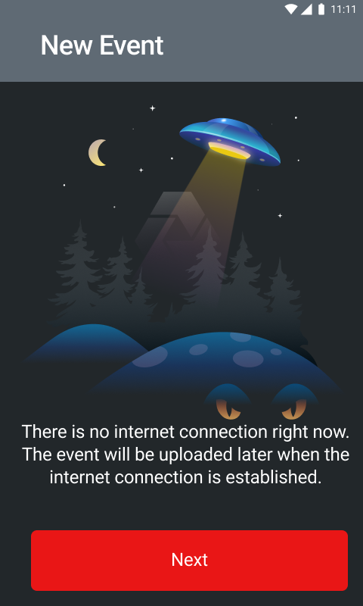

Figure 3.8.11.

After the user clicks the continue button, the User is taken to the home screen to the List of My events.

### Triangulation

The User can supplement his event or supplement the event of his teammate. He needs to go to the event and start the triangulation process.

The triangulation function is developed on the server-side. In the mobile application, the sequence of actions is as follows:

1. the User pressed the triangulate button;
2. The camera opened;
3. the User captured the event (took photos and videos);
4. the results screen is displayed;
5. the User can reshoot a photo/video;

If the User decided to triangulate the event and this event was originally defined as UAP / UFO, the User can choose what exactly they are captured.

The Observables screen is next after the content has been confirmed.

The screen should contain:

. Back button

. Button for getting information about Observables

. List of Observables and the ability to select multiple options

. The button for going to the next step;

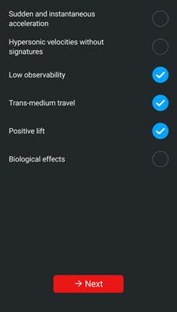

3.9.1. - Select observables

The User confirms the triangulation;

the triangulation event is displayed in the event list;

The triangulated event log cannot be changed after the user clicks the publish button.

Note:

We do not measure the curvature of the Earth.

Instead, the height of the object is measured.

A screen with triangulated event information is shown in the figure.

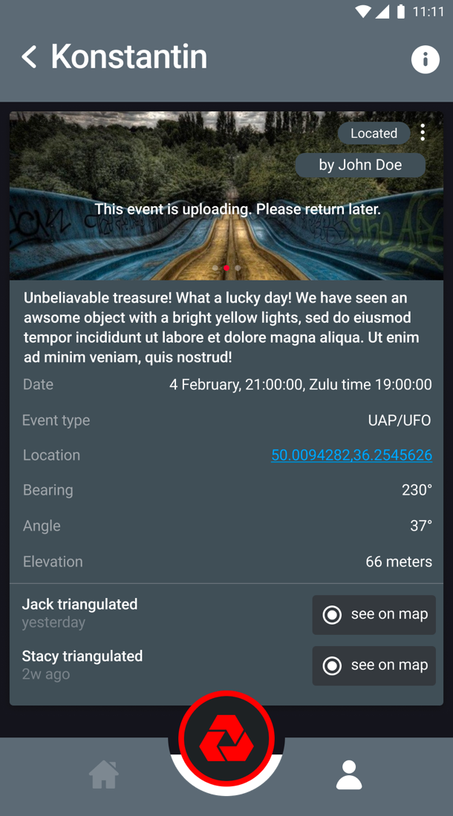

3.9.2. - Triangulated Event

Users can triangulate the event with any amount of photos/videos. In addition, the User can triangulate his own event and his teammate's event. After the event is triangulated, the User can see the mark on the right top of the screen ( Example: Located by John Doe).

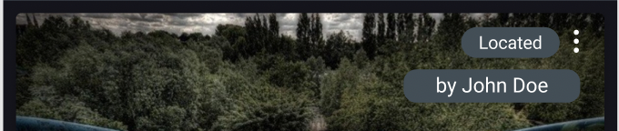

3.9.3. - Triangulated Event Mark

Also, if the event was triangulated more than once, the new information, who and when triangulated the event, appears on the screen.

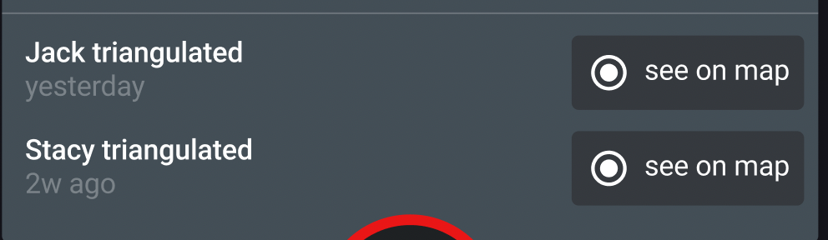

3.9.4. - Triangulated Event Mark

## Story

When User selected adding an event that took place in the past (a Story) the screen is opened and selfie-camera is armed.

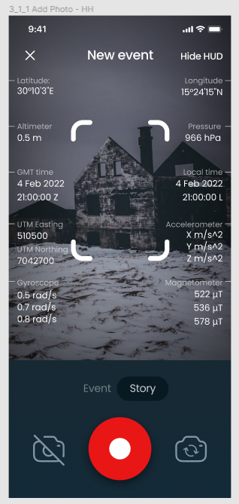

User must press the capture video button to start recording a video where User tells the story about the event happened in the past.

User can

* Start registering the event (recording)
* See a hint 'how to structure a story’
* See the countdown timer that limits the video length
* Stop recording
* Retake the video
* Go next to complete the form

When video content is recorded then User must specify the type of the event on the Story (see enumerations)

User can see the **Info** explaining the details of Observables



When **Story is added** then

* Notification system must be triggered so that users get notified that new story is added
* User can see the list of My events updated
* Users can see the list of Recent events updated

# Events

While on the events screen, the User can see the List of his events and go to the List of events of his teammates.

## Recent Events

This feature for Use in the application shows which three last photos or videos were taken to create a new event or triangulation of an event.

This screen shows a list of three events that other users made.

The screen should contain:

- Section title

- List of events

Each event must contain:

- Event cover

- Location

- Name of the person who took the photo or video

- Button to trigger ‘add to teammates’ feature (when profile anonymization option = off)

- The button, when pressed, will open the details

- Event type

-Debrief (if any)

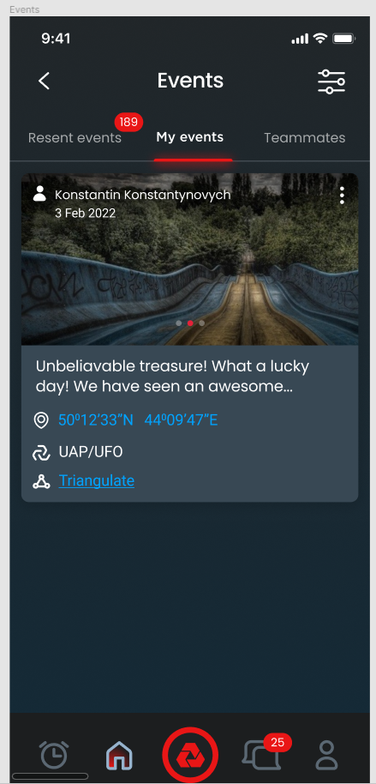

This screen shows the details of the event.

The screen contains:

- Event type (story or event)

- Debrief (if any)

- The name of the event

- Return button

- Photos and videos were taken as part of the creation of this event, and triangulation

- Event description

- Location

- Bearing

- Angle

- Elevation

- List of triangulations and buttons to view on the map (If this event was triangulated)

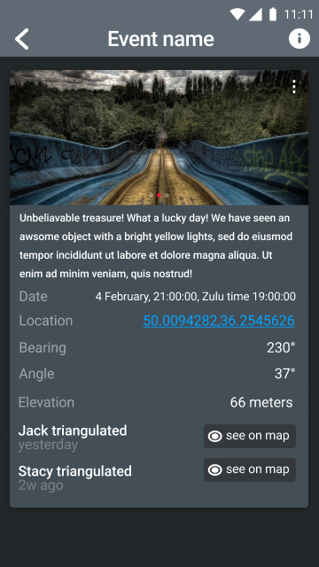

Figure 3.10.2. - Recent Event

This screen shows triangulations on the map.

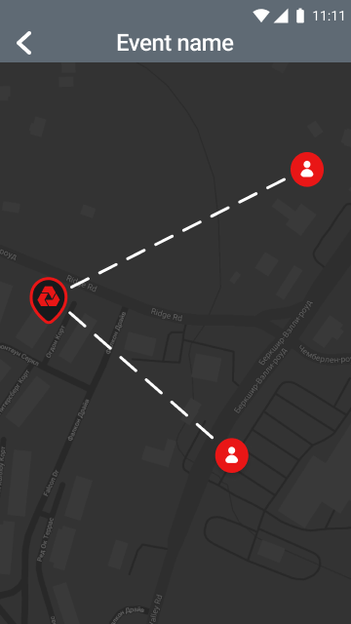

Figure 3.10.3 - Event map

## My events

The User can see a list of their events and basic information on them.

The List of events should contain:

* Event type events + stories
* event block;
* photos and videos of this event;
* date;
* the author;
* description;
* geodata and the ability to go to the map;
* type of event;
* button to triangulate the event;
* the ability to delete an event (Since this is a user event);

When clicking on the event, the User gets to the event's details (Requirement 3.11.3.)

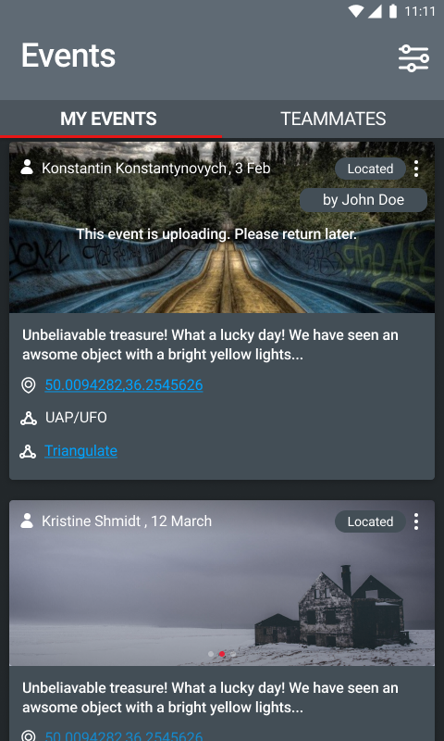

Figure 3.11.1 - My event's List

## Teammates events

The User can see a list of their teammate events and basic information.

The List of events should contain:

* Event block;
* Photos and videos of this event;
* Date;
* the author;
  + User is able to trigger ‘add to teammates feature’ when anonymous setting is off
* description;
* geodata and the ability to go to the map;
* type of event;
* button to triangulate the event.

When clicking on the event, the User gets to the event's details (Requirement 3.11.3.)

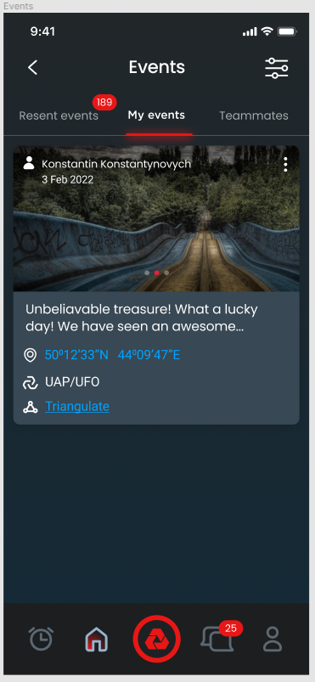

Figure 3.11.1 - Teammates events list

# Event details

The User can see the details of the event.

Event details must contain:

* Photo and video
* Photos and videos of this event
* date
* the author
* type of event
* description
* All the data that is collected from the phone
* Observables (if it is a UAP / UFO type of event)
* List of triangulations
* View profile data button
* button to triangulate the event.
* Debrief

If the event was created as a UAP / UFO category, the event details screen should contain information about the observable . This information is provided only about the observables specified by the event's creator.

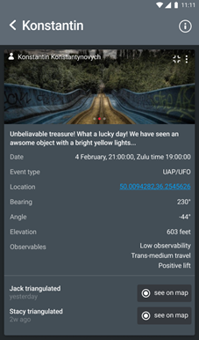

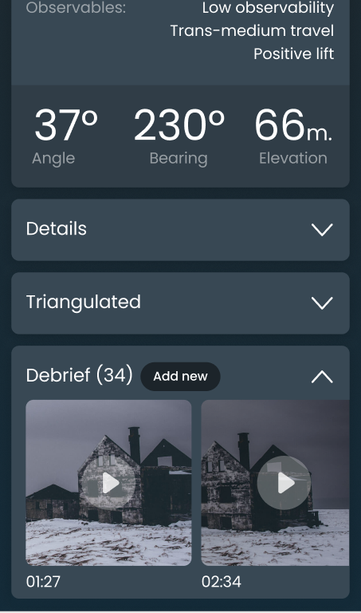

Figure 3.11.3 Event details

If User is the owner of the event

* User can add a debrief to the event
* User can see the debrief to the event
* User can edit the debrief to the event
* User can delete the event

## Debrief

When event is created then User can add a debrief to the given event. Debrief is a detailed information provided by User regarding the parent Event. When adding a debrief then User can

* Record a media content using selfie camera
* See the timer for the max length of the video
* See the hint how to structure the story
* Re-take the video

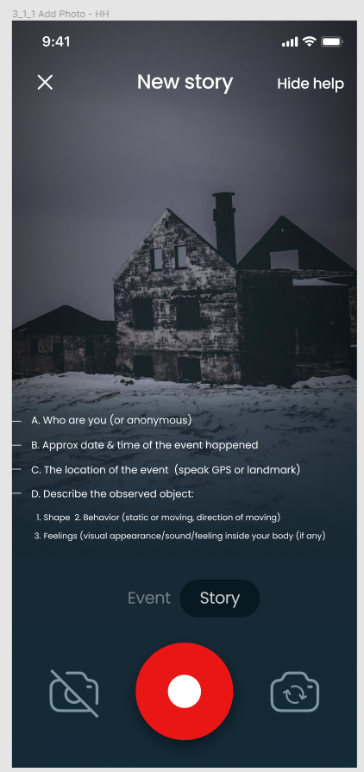

# Chats

Users should be able to chat with each other within the app. The PubNub SDK powers the chat. To start a new conversion (one-to-one or group), each User needs to create a chat in the Phenom system. The system automatically creates this communication in the PubNub system. For a user to create a conversion, they need to be a teammate with the Use. If one of them removes the other from the List of teammates, the conversion remains in effect, but if one of the users decides to delete this chat, none of the users will create a new chat again until they become teammates.

## Channels

After the user signs up, he can see the screen with an option to choose the channels he wants to participate in:

* UFOs/UAPs
* Paranormal
* Cryptozoology
* Miscellaneous
* Phenom Master Chat

|  |  |  |
| --- | --- | --- |
| Chat name | Description | Image |
| UFOs/UAPs Chat | Any discussions about the UFO/UAP Phenomena and active investigations. | Ufo clipart cool, Ufo cool Transparent FREE for download ... |
| Paranormal Chat | Any discussion about the Paranormal Phenomena and active investigations. | Ghost Free PNG images, Halloween Ghost, Scary Ghost, Ghost ... |
| Cryptozoology Chat | Any discussion about the Cryptozoology Phenomena and active investigations. | Bigfoot Clipart at GetDrawings | Free download |
| Miscellaneous Chat | Any discussion on any Phenomena not discussed or none active investigations. | Dancing Question Mark Clipart | Free download on ClipArtMag |
| Phenom Master Chat | Any feedback and discussion on Phenom the app. |  |

The channels are common, and all users can be there.  The channels are created by developers and the title, image and description of the channels can be changed by Admin only.

The user can skip choosing the channel, can choose all channels or few of them.

The user can choose the channels he wants to participate in just once. After that, the user can leave the channel and add any other user, and be added to the other channel by another user.

The Channel is managed by the Admin. The admin can add, delete users and delete messages. The admin is assigned by developers via the Firebase panel.

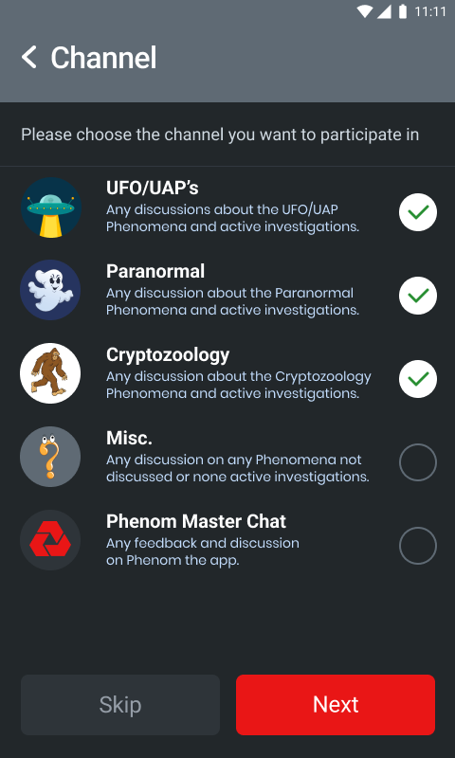

Figure 3 - Channels list

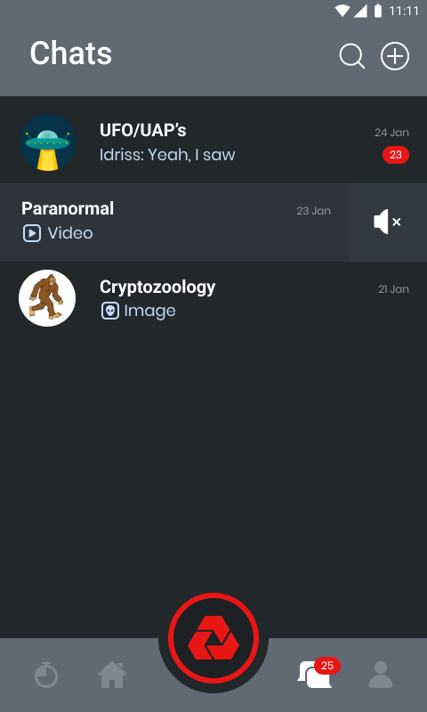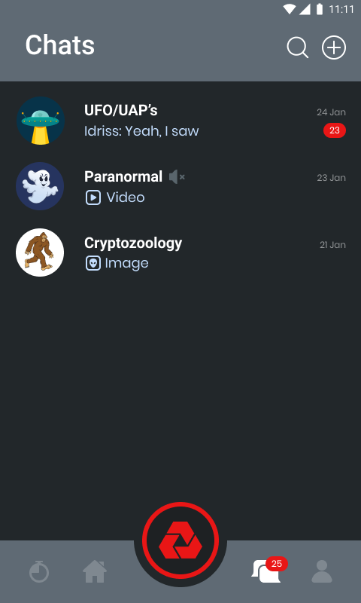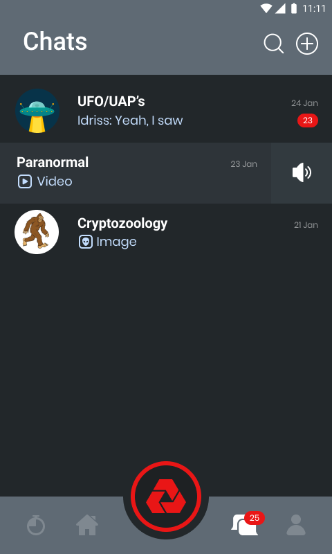

Figure 4 - Mute/Unmute Channels

## Chat list

All chats are displayed on one screen in a list sorted by the date of the last message in this chat.

This page is considered the home page for chats and always opens when you click the "Chats" button in the tab bar.

Each chat in this List must contain such attributes:

1. Chat name
2. Last chat message
3. Chat photo
4. Time (or date) of the last message
5. The number of new messages in this chat
6. Notice of mention

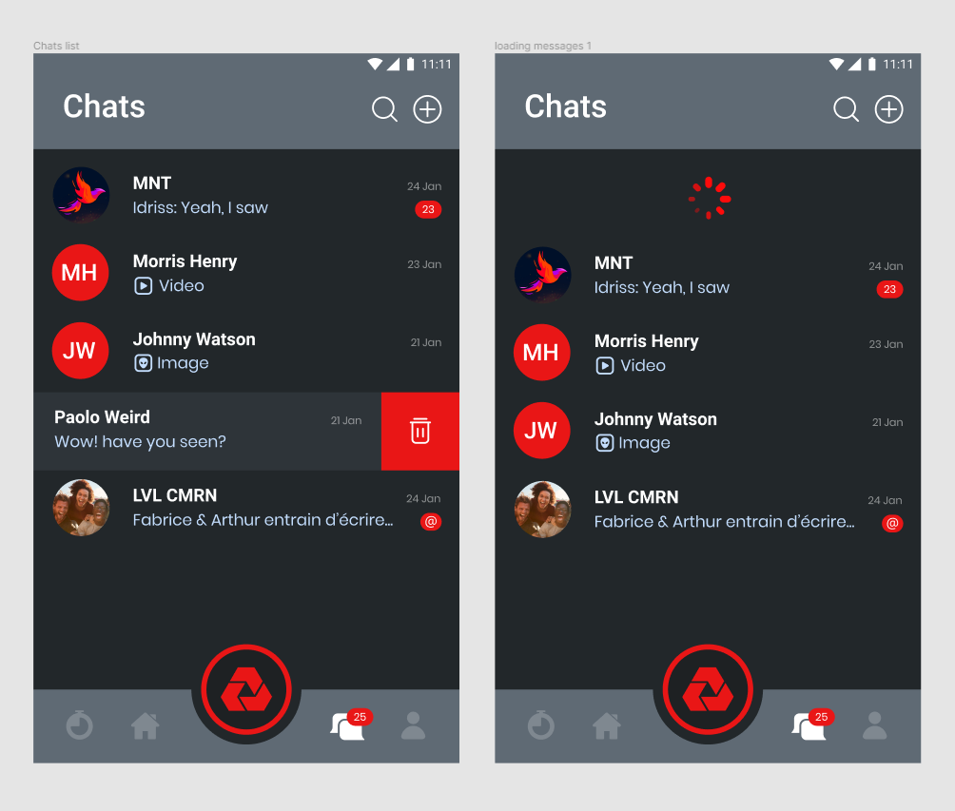

Figure 3.12.1 - Chat list

If the last chat message was sent on the current day, the system displays the time of that message. If the last chat message was sent on a different day, the system displays the date of the message.

The User can remove a chat from the chat list. If this is a group, the User automatically leaves this group; if he is the last member in this group, the system deletes this group. If this is a one-on-one chat, the system removes this conversion from both interlocutors.

When you swipe down, the system updates the chat list.

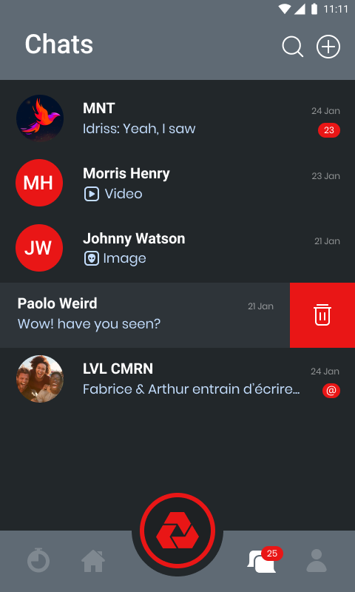

Figure 3.12.1.1 - Delete chat

## Create a chat

Users must be given the ability to create new chats. A button on the screen with a chats list means creating a new chat. To start a correspondence with someone, the User needs to create this chat inside the system. The User can add only his teammates to the group or create one-to-one conversations. If the User does not have teammates yet, the system displays a dummy screen and prompts him to find teammates.

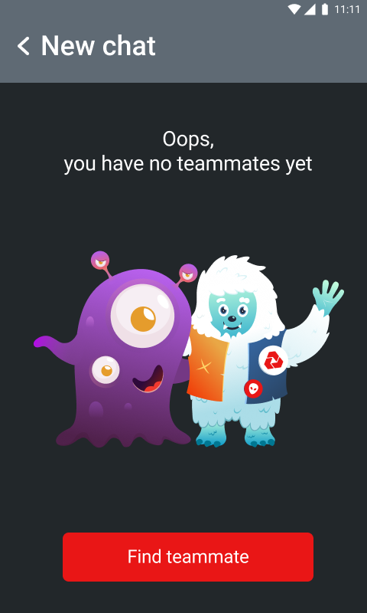

Figure 3.12.2 - No teammates yet

The flow of creating chats is described in the use case below.

|  |  |
| --- | --- |
| Use case name | Creating a new conversion |
| Description | To communicate with other users, you need to create a new chat |
| Actors | User, system |
| Pre-conditions | the User is already registered in the system, and he already has a contact list |
| Main flow | . A user clicks on the button to create a new chat |
|  | . The User selects the interlocutor |
|  | . The system creates a new chat |
| Alternative flow 1 | Alt1.2 The User selects multiple users. |
|  | Alt1.3 The system creates a chat. |

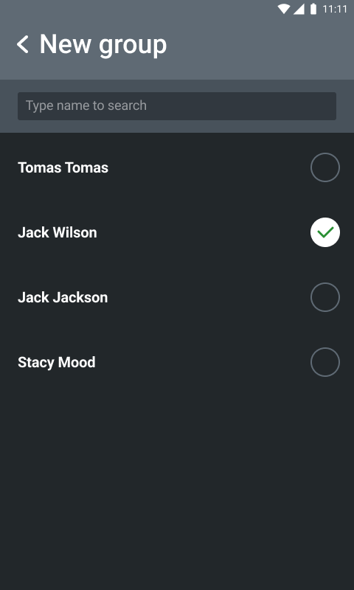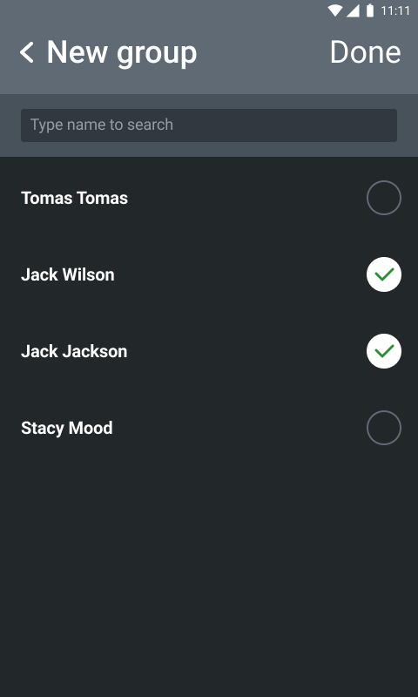

Figure 3.12.2.1 - Chat selection

To add interlocutors to a group chat or create a private chat, users can search for other users by entering their names in the search field. It is also a field for monitoring, which the User will include in the group.

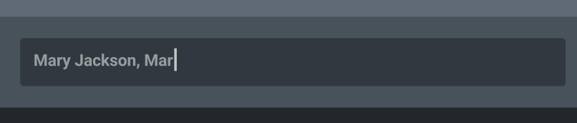

Figure 3.12.2.2 - List of users who are already marked

After the system creates a chat, by default, the title contains the first two usernames and information about how many other users are in the chat besides the owner. The initials of the first member of the group are used as a photo. After the group is created, the system publishes the system message "(Username) created a chat".



Figure 3.12.2.3 - Default group name and photo

## Search chat

The User should be able to find the necessary chat by the name or the interlocutor's name.

The User enters the name of the interlocutor or the group's name, and the system makes a search and displays options in the form of a list.



Figure 3.12.3.1 - Search

If the search does not return any results, the system displays a stub screen.

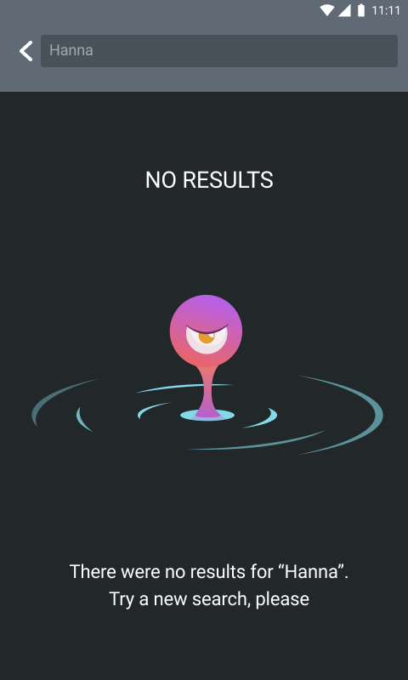

Figure 3.12.3.2 - No search results

## Chat screen

All correspondence between users takes place on the chat screen.

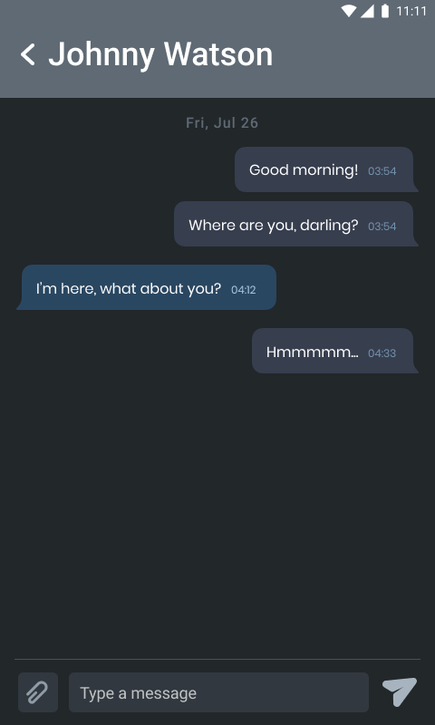

Figure 3.12.3.2 Chat screen

## Chat attributes

The chat screen should be grouped by date, have messages, a field for writing a message, a button for sending media, system message. Chats have the following attributes:

1. Date grouping

All messages in the chat are grouped by the date they were sent and separated by a special image with the date.

1. System messages

System messages help users understand what changes are happening inside the chat. System messages can have text like this:

(Username) сreated a chat

(Username) added to chat (Username)

(Username) has left this conversation

## Message

Each message should contain:

* Text of message
* Form
* Time dispatch

A received message should contain:

* Sender name (Figure 6)

The sent message should contain:

* Sent / Read (Figure 7)

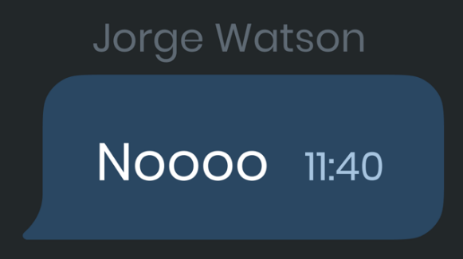

Figure 3.12.4.1. - Example of the received message

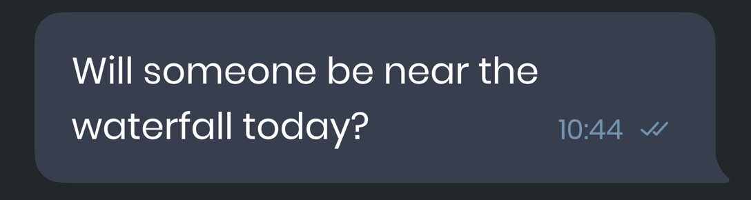

Figure 3.12.4.2. - An example of a sent message

## Mentions

The User can mention his interlocutor in his message. After this mention, the User who has been mentioned receives a notification.

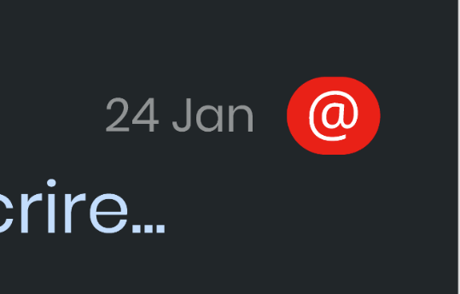

Figure 3.12.4.3. - Mention notification

## Links

Users can send links in a message, and these links will open as external links using a standard browser.

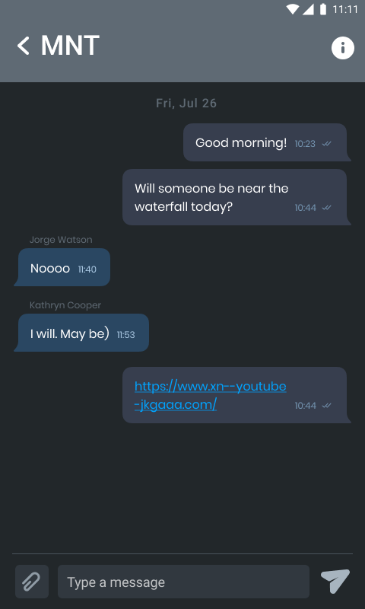

Figure 3.12.4.4. - Links

## File upload

Users can share files in chats

The User clicks on the "add media" button to send a file and selects one of several options-

* Take a Photo
* Take a Video
* Choose from Gallery
* Choose document
* Cancel

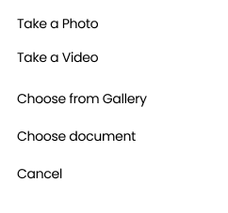

Figure 3.12.4.3 - Add File Dialog Box

## Upload Photo

The User can send a photo in chat. Jpeg and PNG files are displayed in preview format inside the application. Photos that do not conform to the standards for preview presentation are sent as files and opened using the preinstalled software on the device.

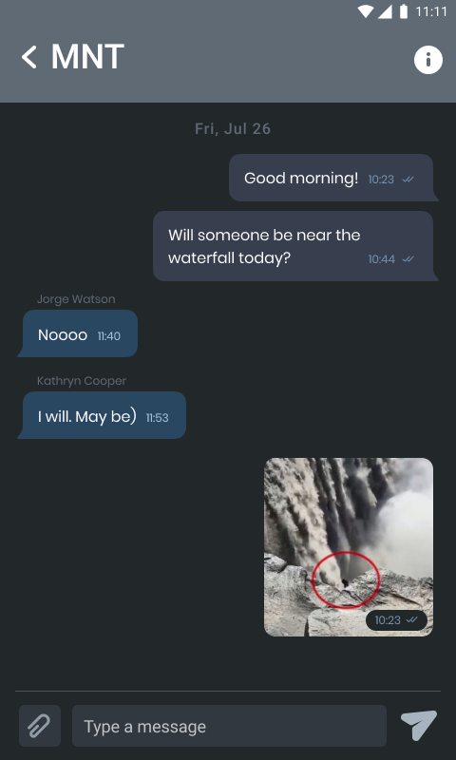

Figure 3.12.4.3.1 - Preview photo in chat)

When the User opens a supported photo format, this photo is opened inside the application.

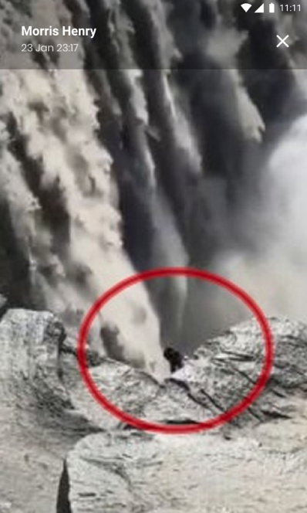

Figure 3.12.4. - Photo review

## Upload video

The User can send a video to chat.

Suppose the video sent to the chat is in MP4 format. Videos in chats are displayed as a preview. Videos that do not conform to the standards for preview presentation are sent as files and opened using the preinstalled software on the device.

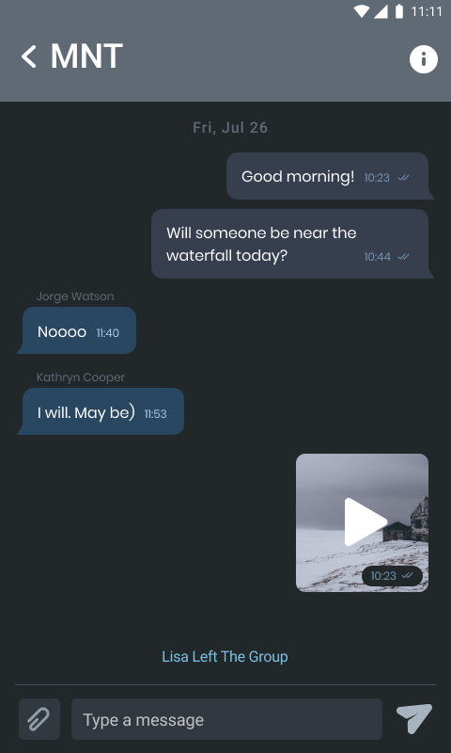

Figure 3.12.4.3.2. - Video

This video opens inside the application. The User can watch the video, pause, continue watching, rewind the video.

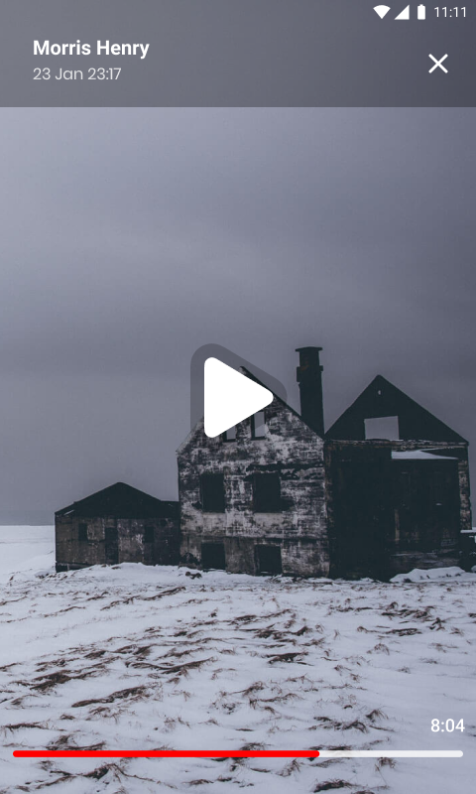

Figure 3.12.4.3.2.1. - Video player

## Upload Document

The users can send files to other users in chat. Document formats that are required – Doc, PDF, AP. Additionally - all photos and videos that do not meet the standards for presentation in the form of previews are sent as files and will be opened using the preinstalled software of the device.

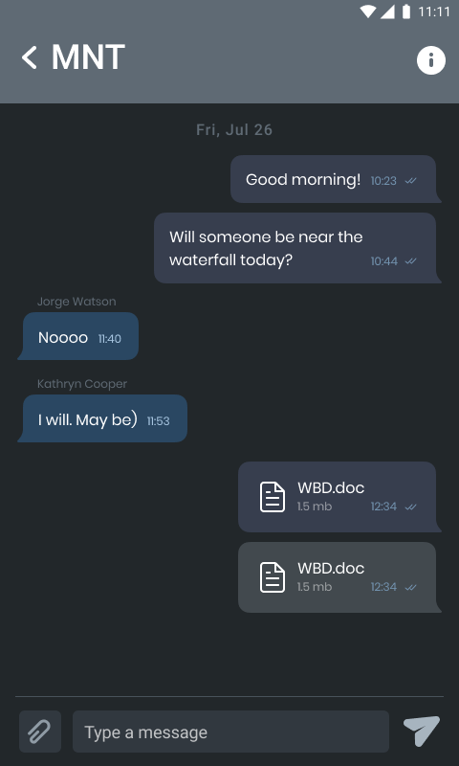

Figure 3.12.4.3.3. - Send a Document

## Unavailable files

If a photo, video, or document is not available for viewing, the system displays this by making the file transparent. Then, when the user tries to open it, it shows the notification "This file is no longer available for download".

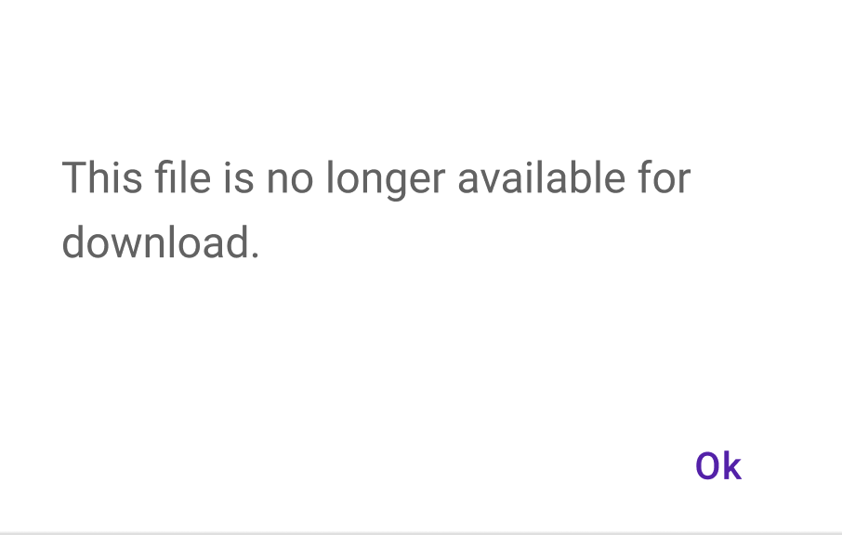

Figure 3.12.4.4. - File unavailable notification

## Group chat settings

Each User can change the group setting. For example, the User can change information, add new users, delete users and leave the group.

## Editing information and photos

Each User can go to the group settings and change the name and photo of the group.

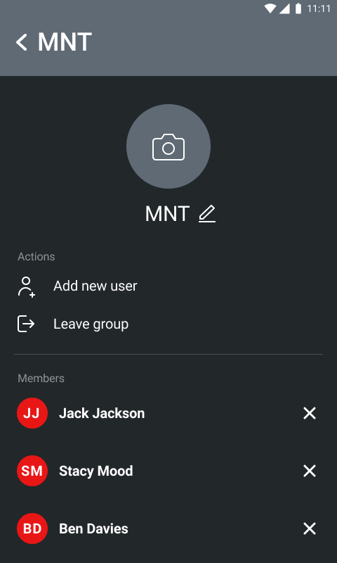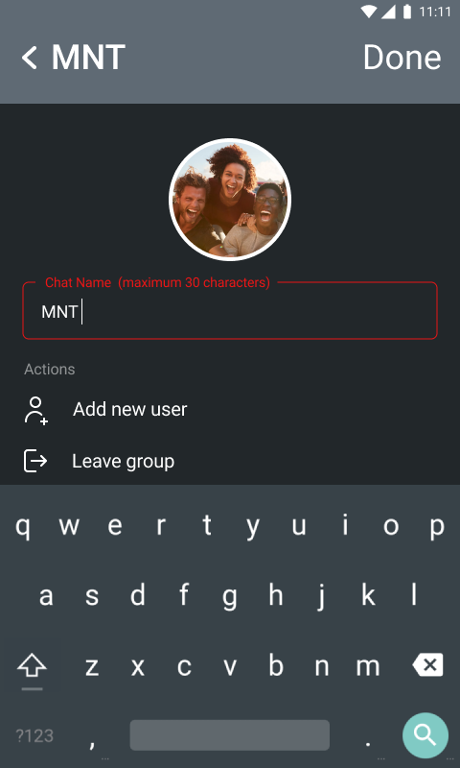

Figure 3.12.4.5.1. - Change group information

|  |  |  |  |  |
| --- | --- | --- | --- | --- |
| **Field Name** | **Field Type** | **Required** | **Accepted Values** | **Field Length** |
| MNT | Input Field | Yes | Characters, Digits, and Symbols | Min Length: 1 character  Max Length:30 characters |

The name of the group limits the system. However, the name cannot exceed 30 characters for users' convenience. If the user entered value exceeds this limit, the system should generate an error and notify the User.



Figure 3.12.4.5.1. - Limit the number of characters in the group name

## Invite User

Anyone in the group can add a new member to the group. To do this, he clicks the invite button and goes to the screen of the List of users he wants to add.

To add a new member to the group, the User must select who he wants to add to the chat among his teammates.

After the User has added a new group member, the system adds the system message "(Username) added to chat (Username)."

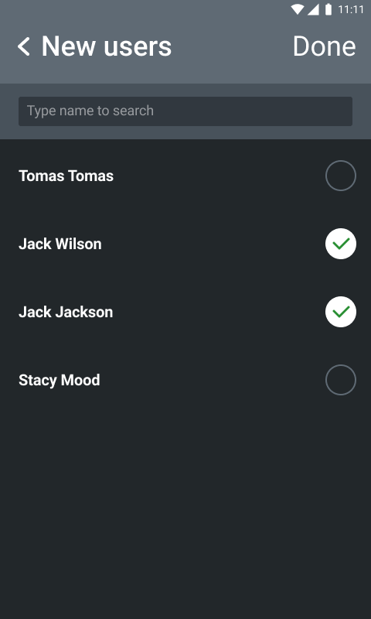

Figure 3.12.4.5.2. - Add new User

## Delete User

Group members can remove other group members. To do this, he needs to select which User needs to be deleted and confirm this.

After the user has removed the group member, the system adds the system message "(Username) removed from chat (Username)".

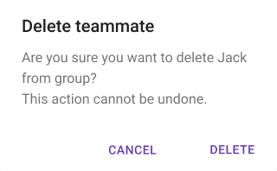

Figure 3.12.4.5.3. - Delete teammate

## Leave the chat

The User can leave the chat. First, he needs to choose to leave the chat and confirm it. After the User confirms leaving the chat, the system deletes it and adds the system message "(Username) has left this conversation" to the chat.

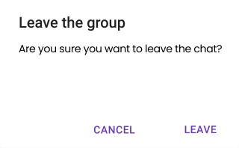

Figure 3.12.4.5.4. - Leave the group

# Profile

When the User presses on "Review profile" the (Figure 3.12.) opens.

The screen contains the next data:

1. Button to go to teammates
2. Phenom Registration code
3. First name;
4. Last name;
5. Email;
6. Cell Phone;
7. State or Country code;
8. End-User License Agreement;
9. Log out functionality.

*Acceptance criteria:*

* The User can't change his personal info;
* the same screen is shown for your Profile and your friends.
* The User can log out of their account.
* Users can open "End User License Agreement" and read.

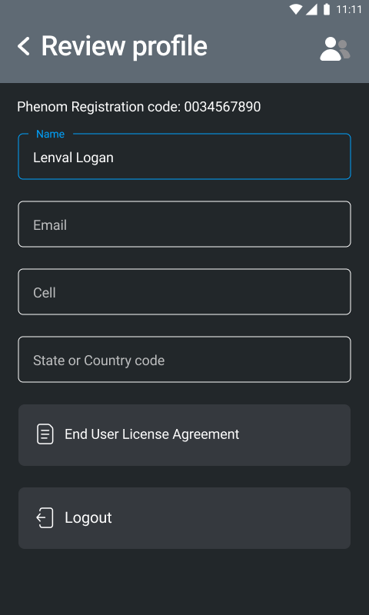

Figure 3.12 - User profile

# Teammates

## My Team (Team Creator) teammates management

### Creator can search and add teammates

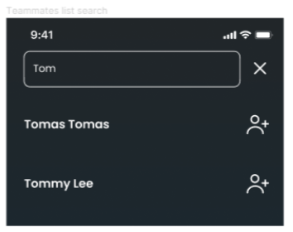

The User can add other users to their team.

The workflow diagram is shown on the following screen:

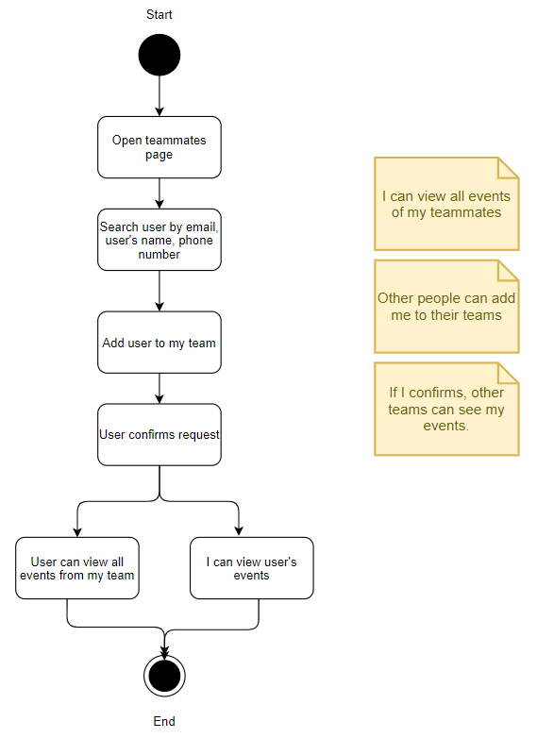

Figure 3.14. Teammates workflow diagram

### My Team. List of teammates

The User can see his teammates in the following way:

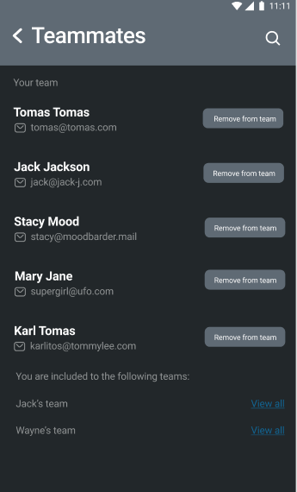

Figure 3.14.1 Teammates screen

A user can see his team and all teams where a user is included.

A user can search for teammates (see "Search" section.)

If a user doesn't have a teammate on his team, the button "Add to my team" is shown. If this teammate is already on his team, the button is changed to "Remove from the team".

When a user presses the button "Add to my team," another user who got a request sees the following screen, where they can either "Confirm" or "Decline" a teammate.

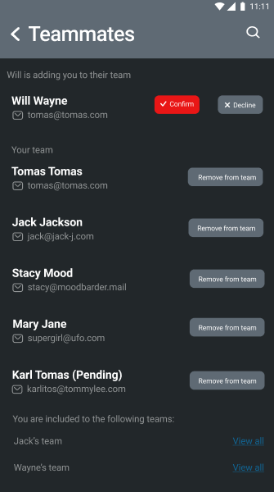

Figure 3.14.2 - Confirm teammate's request

When a user confirms a teammate's request, this User is included in the team and can view all team members' events in the team.

When a user confirms the request, he is shown in the team with Pending status. This User cannot see all team members' events in the team in status pending. A user who added this teammate can revoke his request by clicking the "Remove from team" button.

A user can view all teams where this User is included with the team lead's first name.

The team lead is the User who added this User to his team.

A user can view somebody's team (if included in the team) by clicking the "View all" link. It leads a user to the following screen:

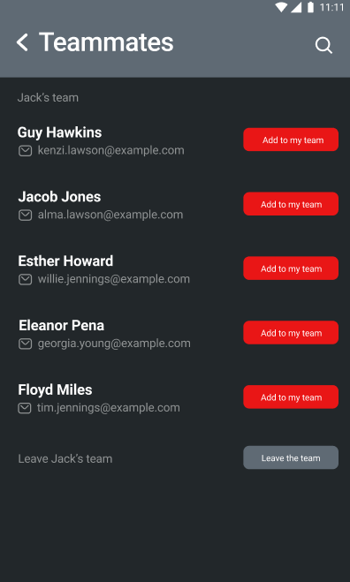

Figure 3.14.2 Jack's team screen

A user can see all teammates of his teammate.

A user can add teammates to his team by clicking the button "Add to my team. Then a request is sent, and the same logic as described above applies.

A user can leave this team by clicking "Leave the team. The following modal is shown:

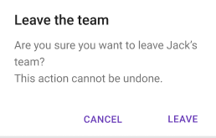

Figure 3.14.2 - Leave the team

If a user clicks the button "Leave", this team is not shown to the User, and the User is redirected to his teammate's screen.

If a user clicks the button "Cancel," the action is canceled, and the message is hidden from the screen.

A user can search his teammates by a user's name (first name, last name), email, and phone number.

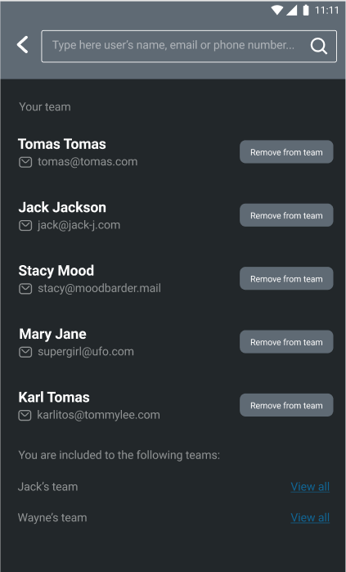

Figure 3.14.3 - Search

When a user gets results, it shows users in the following way:

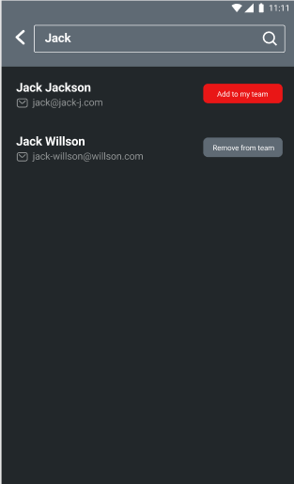

Figure 3.14.4 - Search results

If a user is anonymous, nobody can search this User.

Admin can view all users in the Firebase, Firebase anonymous users.

Admin can log in to the Phenom app, but there is no visual presentation that Admin has other rights.

### Requests to join my team

Team creator receives requests from other users who wants to join my team. Creator can see them in the list

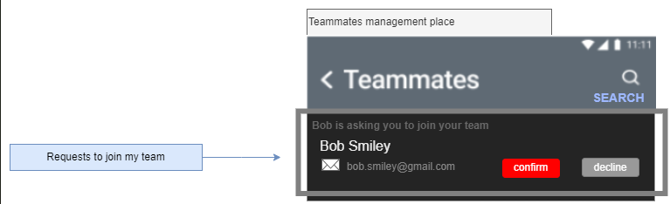

When Creator **confirmed** the request then

1. Requestor is added to the team
2. Request disappears from the list
3. Requestor got notified (see respective paragraph)

When Creator **declined** the request then

1. Requestor is not added to the team
2. Request disappears from the list
3. Requestor got notified (see respective paragraph)

### Notification

A Team Creator can see the notification coming when Requestors are sending requests to join ‘My Team’.

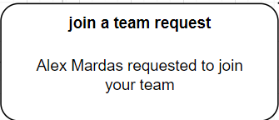

**Title**: join a team request

**Body**: <username_requestor> requested to join your team

**Actions**: no action buttons

**Navigation**: navigate to the Main-Profile-Teammates screen

## User (requestor) can search the team and ask to join

### Searching and requesting

A User can search the list of existing teams and initiate a process of joining to the desired team.

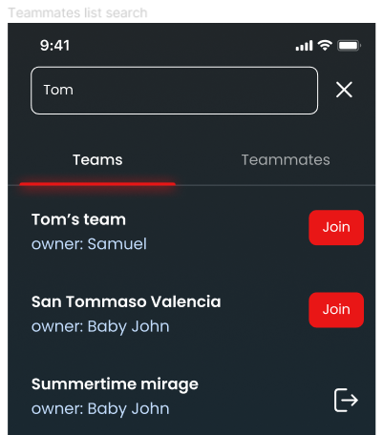

When a desired team is presented in the list, a user can request to join them. The request is sent to the Creator of the team.

### Requestor can monitor the status of the request

When request is sent then the Requestor can **monitor** the status of the request by seeing the status next to the request.

### Requestor can cancel the request

When the request to join somebody’s team is sent but Creator of the team not yout responded then Requestor can cancel the request. When request is canceled then it must disappear from the lists= of requests for both: requestor and team creator.

### Notification

When the request is sent then Requestor is waiting for the Team Creator’s decision.

When decision is made then Requestor can receive and see the notification.

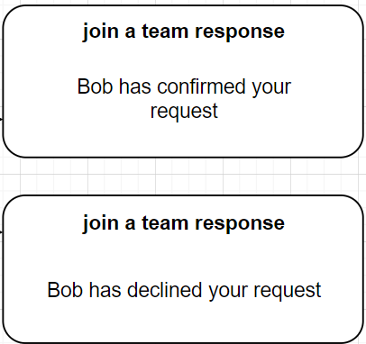

**Title**: join a team response

**Body**: <username_teamcreator> has <confirmed/declined> your request

**Actions**: no action buttons

**Navigation**: navigate to the Main-Profile-Teammates screen

# Team mate profile

When switching to a user, the system displays a list of events that this User has created and details in requirement 3.11. But if these two users are not teammates, they cannot triangulate each other's events. The User has the opportunity to view the personal information of a teammate (or not yet a teammate).

Teammate profile contains:

* Name
* Email
* Phone number
* State or country code

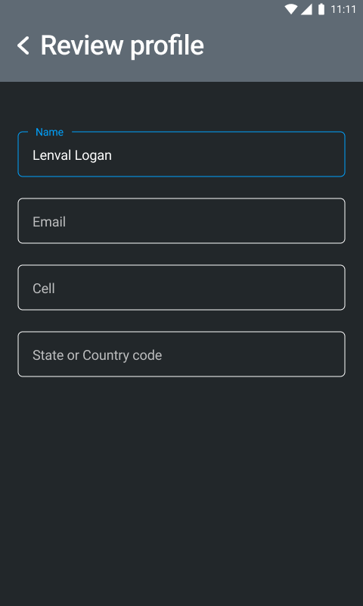

3.15.1. - Review profile

# Settings

When clicking on the settings button on the home screen, the User is taken to the settings screen.

The User can configure the following parameters:

Video duration

-User can specify a flag ‘Phenom can contact me’ (I/O)

-Video length can be 15 or 30 seconds

Whether to continue recording video if the User has not stopped recording.

- The User can enable or disable this option.

Users can specify how many write cycles the system should record.

- It can be 5 or 10 cycles.

Users can select metric distance measurement systems.

- It can be meters or feet.

The User can enable the anonymous mode, and no one can find him in the search.

The User can turn on and off the setting for downloading events via cellular communication.

The User can choose the format in which data will be shown on the recording screen – imperial or metric.

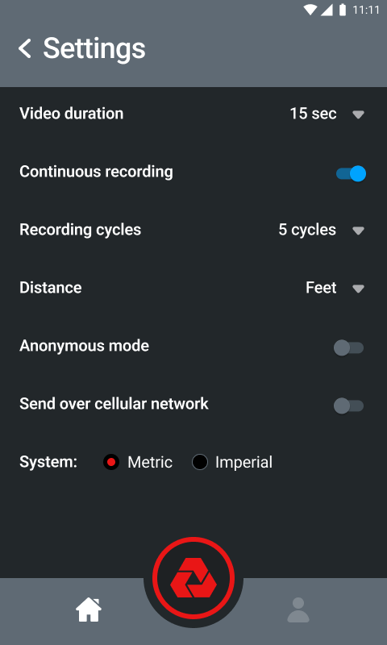

Figure 3.16. – Settings

# Advertisement

In order to monetize the application, advertising will be added using the AdMob service. The advertisement will be shown on three screens.

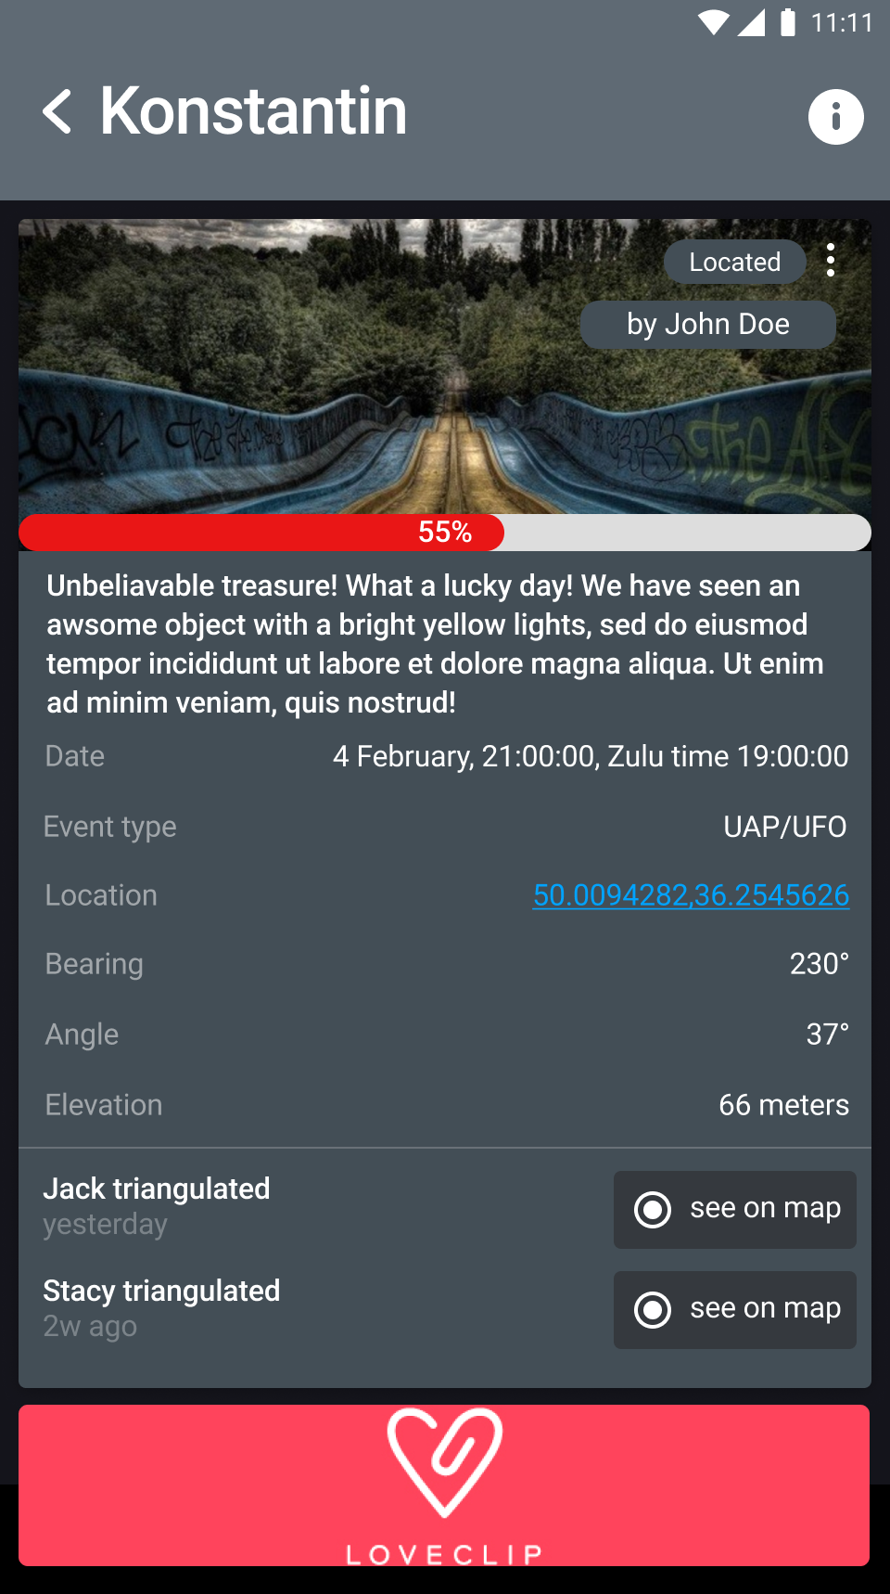 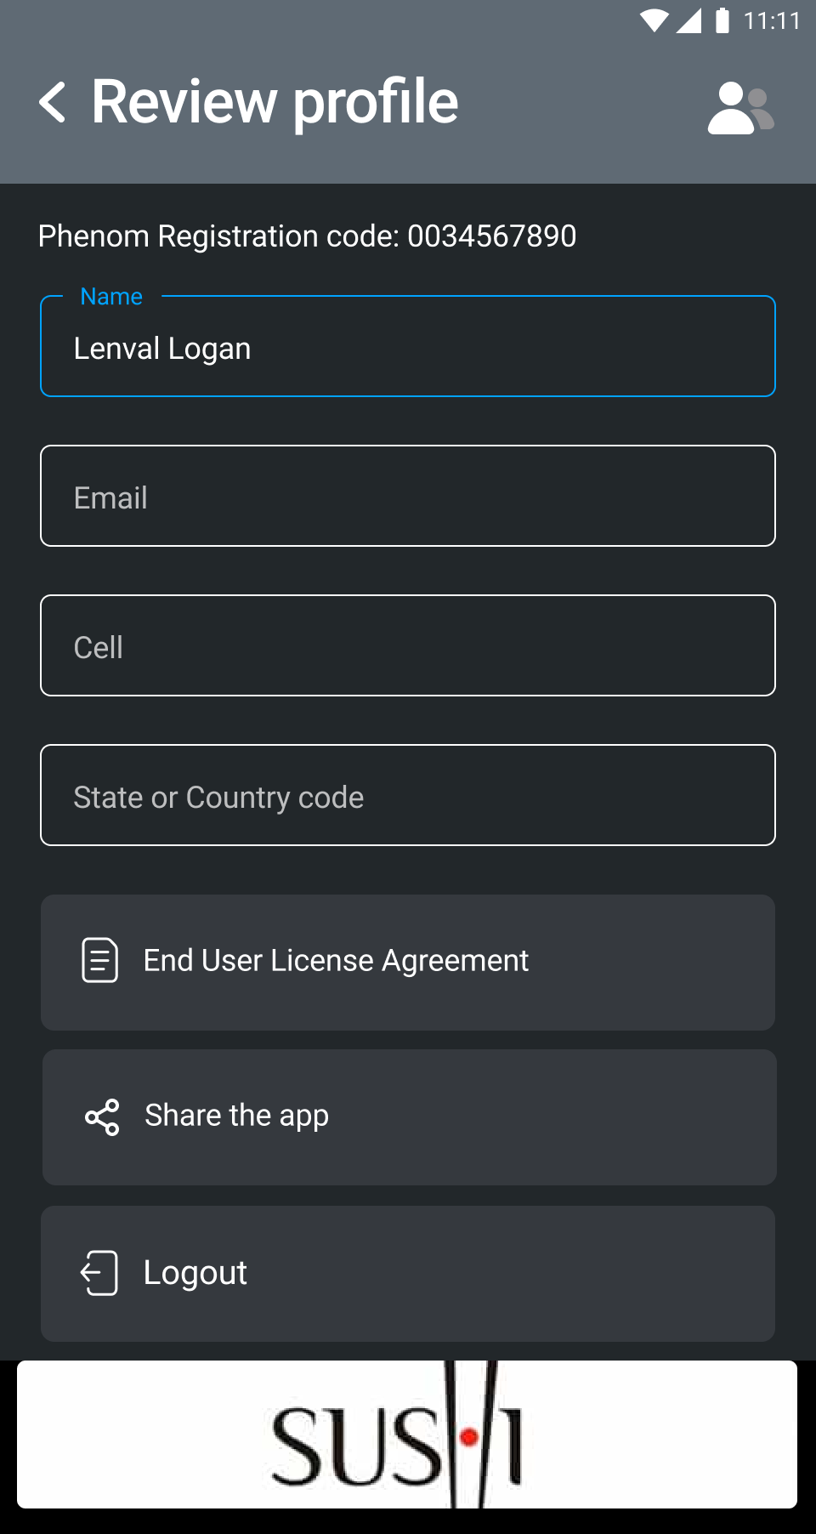 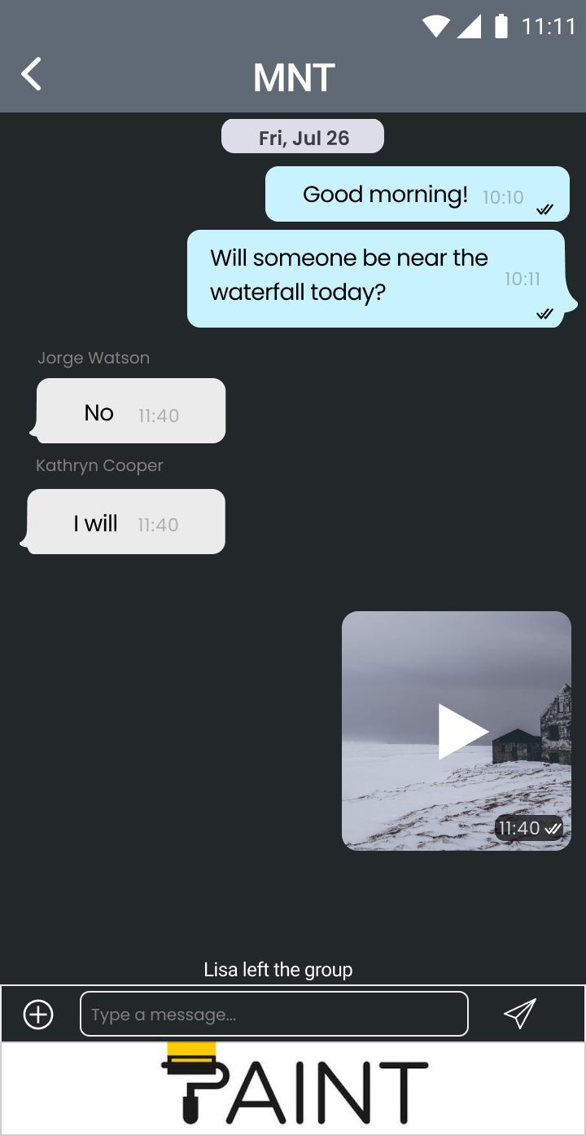

Figure 5 - Wireframes Ads

Advertising has the form of a banner, and is located at the bottom of the screen. To read more about banner click on the link:

https://developers.google.com/admob/android/banner

Ads are shown only when the internet connection is available. In other cases, the banner disappears.

# Deployment

For deployment we need:

1. Png application icon (512x512)

2. Application name (50 characters maximum)

3. Short description (80 characters maximum)

4. Full description (4000 maximum)

5.2-8 screenshots (which you would like users to see along with the description)

6. Baner (graphic picture 1024x500)

7. Link to the privacy policy.  
Short description:

Phenom is a mobile app for collecting, analyzing, and reporting UAP Data.

Long description

•      Phenom is an Android mobile app initiative to build the world’s most comprehensive intelligence tool for collecting, analyzing, and reporting Unidentified Aerial Phenomena and other Unexplained Phenomena.

•      Phenom is the official app for PHENOM LLC, an organization dedicated to investigating the anomalous phenomenon such as UFO/UAPs, Cryptozoology and Paranormal activities. And shall include

•      ●    Phenom Synch alerts, other teammates and users to try and witness your UFO event in real time. Users can upload a picture or video, and input a description of a sighting and other users will receive an alert with its exact location based on Bearing, Range Altitude (BRA) and other real-time data. They can then corroborate the report with their own picture, video, or description.

•      ●    Phenom 3RE, Users will always be able to see the last 3 events captured globally and eventually be allowed browse reported sightings on a map or in a chronological list.

•      ●    Phenom shall eventually give teammates users in-app access to much more complete website, which includes information about findings, sightings and unusual activities, an archive of articles, and a detailed form for reporting a UFO.

•      ●    Phenom shall provide all its data to is backend called PHENOMaiNON.

•      The PHENOMaiNON platform is a Cloud Native AI platform designed to ingest, analyze and predict data-driven events focused on subject matter specific to unexplained phenomenon.

•      The PHENOMaiNON functionality will include the collection, storage, search, and analysis of information regarding all events, eyewitness accounts, and data recordings that could shed light on anomalous advanced technology and capabilities world-wide. The database will be able to ingest various formats, languages, and data sources ranging from civilian, industry, academia, law enforcement, the United States Government, and other sovereign entities. This also includes data sets from aviation authorities, climatic data, sonar, and other like-sources.

•      The primary objective and purpose of PHENOM are to:

•      •          Promote global cooperation and collaboration through Education, Experience and Exposure of unexplained Phenomena based on analysis of evidence and data collected.

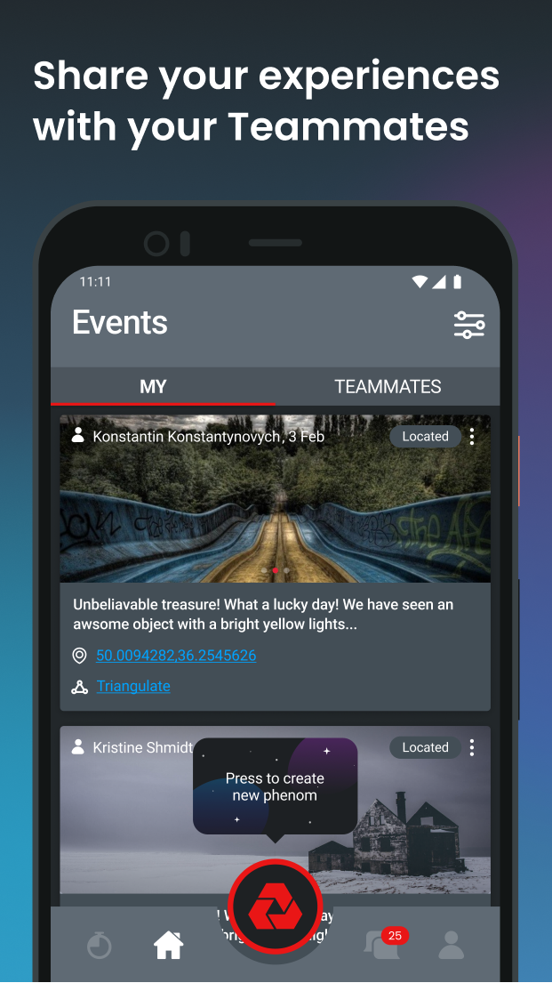 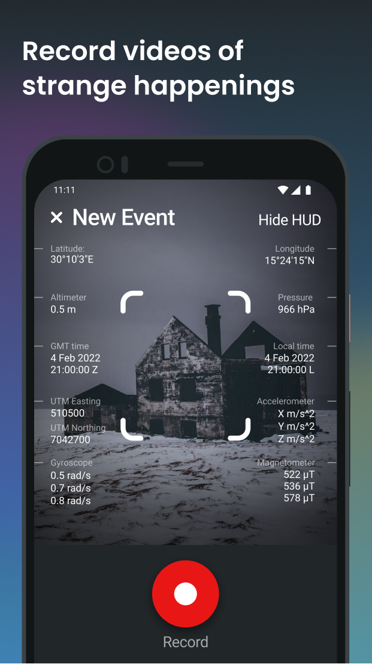 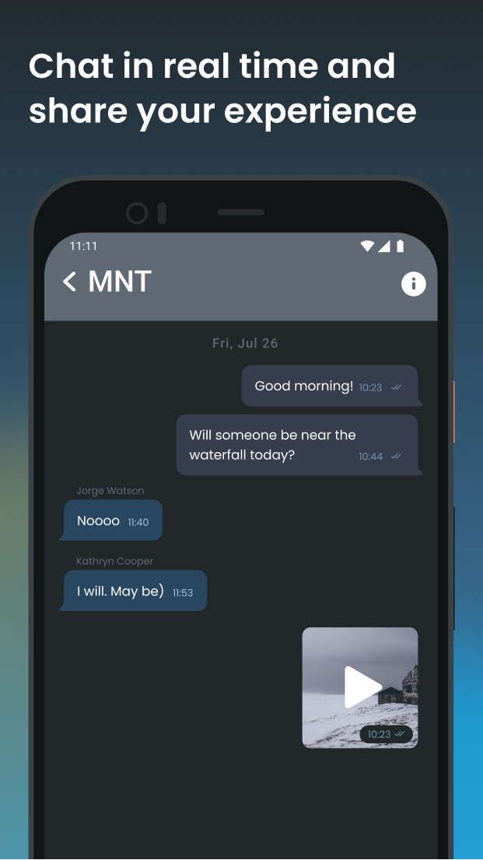 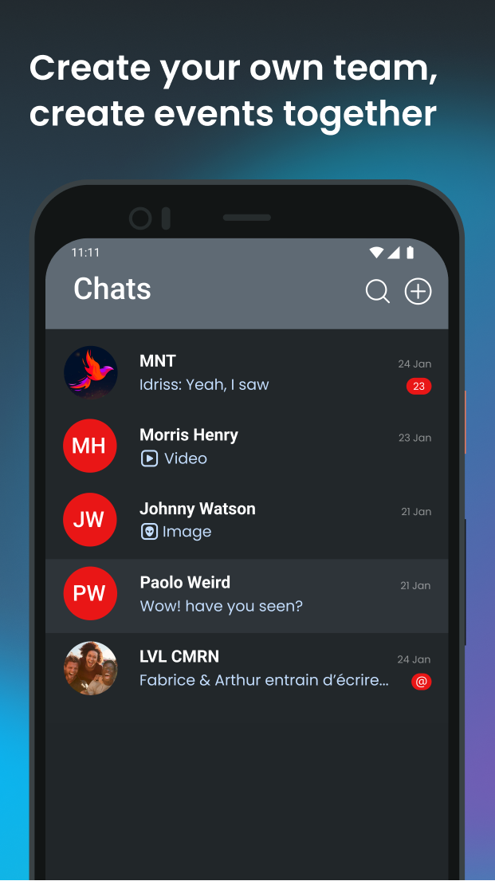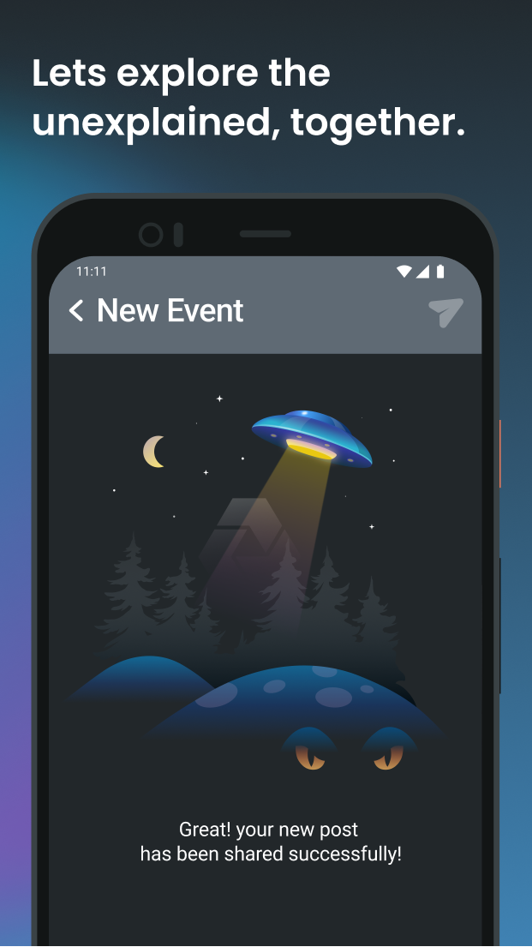

Banner:

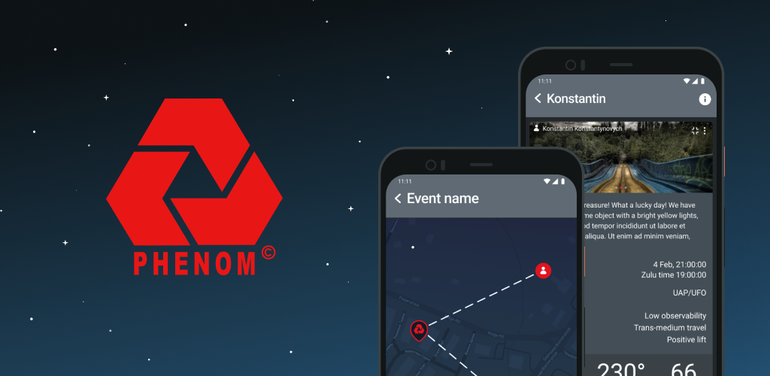

Reporting a profile

When user detected weird behavior by another user or some content is abusive then there is a function to Report an abusive profile or content.

To report an abusive content User can trigger the process for each available content.

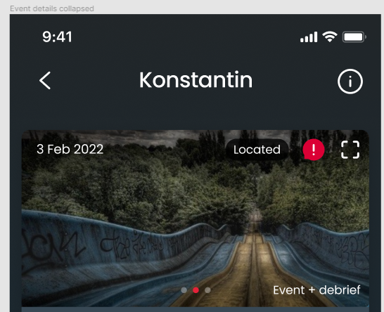

When process is triggered then User can specify what is to be reported

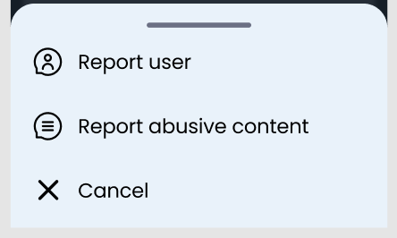

When ‘Content’ is specified then content becomes unavailable (blurred) for the Reporter and respective record is added to Database so that Admin of the system can find and see the content that is reported across the system.

# Reporting a User (Content) instruction

## Blocking Events (from Admin console)

Open Firebase console (this is the link to prod version)

https://console.firebase.google.com/u/0/project/phenom-7ee1a/overview

List of Reported events:

1. Go to “Firestore Database” → “phenom”  
   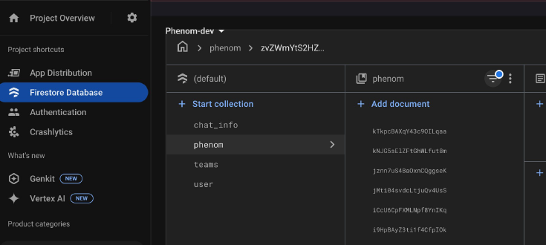
2. Click on the button  and enter “reported” to the query   
   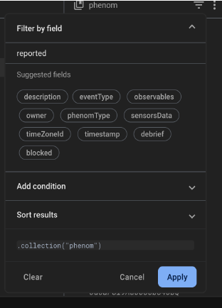
3. Add condition and press “Apply” and then, you get list of reported events  
   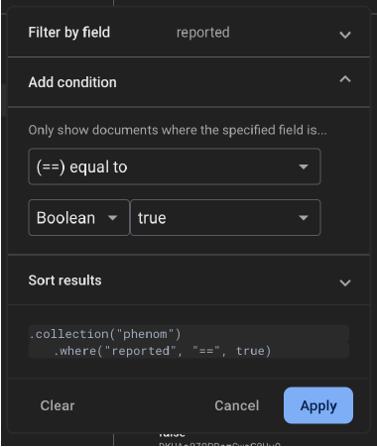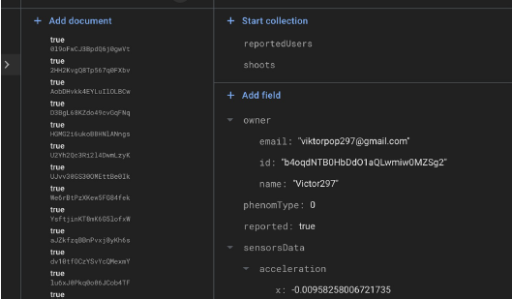
4. To block event tap “+ Add field” and enter data after that the event should be blocked  
   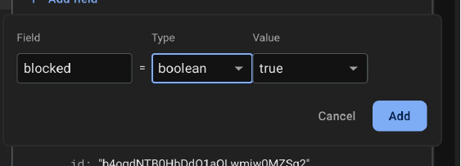

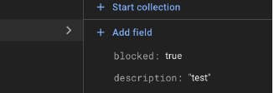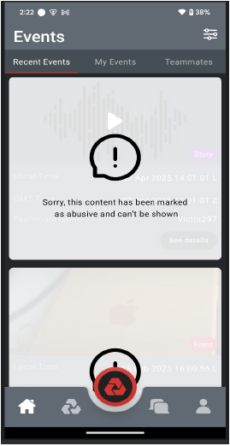

## Blocking User (from Admin console)

Open Firebase console (this is the link to prod version)

https://console.firebase.google.com/u/0/project/phenom-7ee1a/overview

List of reported users:

1. Go to “Firestore Database” → “users”  
   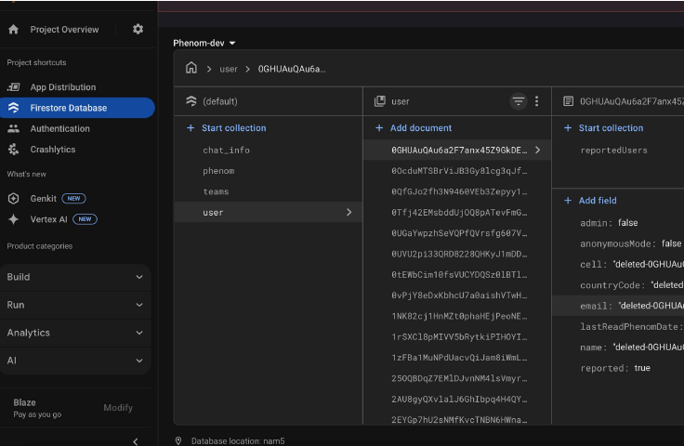
2. Click on the button and enter “reported” to the query  
   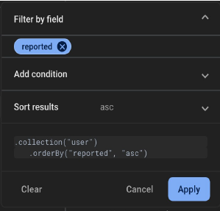
3. Add condition and press “Apply” and you get list of reported users:  
   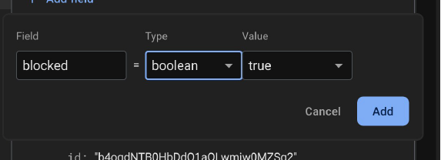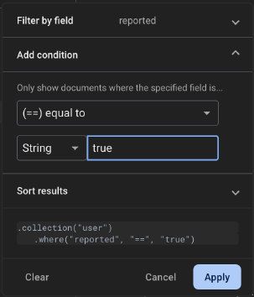
4. To block user: tap “+ Add field” and enter data and the user should be blocked  
   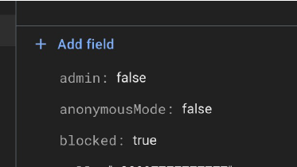
5. When this field set to “true”, Firebase Cloud Function automatically disable this user in Firebase Auth (we no need to block user here manually, but you can check if it is disabled)  
   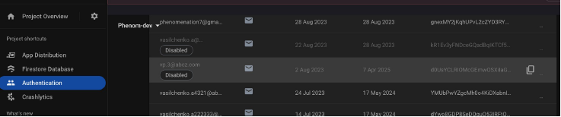
6. A blocked user should be immediately logged out and a message should appear after attempting to log in.  
   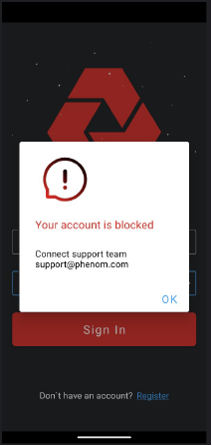
7. Please edit any data in Firebase storage very carefully, as changes are applied immediately and cannot be undone.

Update of the Phenom app

app version=X.Y.Z

Force update flag = I/O

## Android

For the Android app the flow for automatic updates is considered:

**Flow**

1. Dev team edits the app version parameter
2. Dev team releases a new version of the app to the Market
3. When app loads on the client side then it performs the comparison of the versions
   1. When version is changed then app asks a User to install updates
   2. Force update flag makes the update as a must and doesnt allow User to proceed without updates
4. User can install updates

## IOS

For the IOS app update flow is based on the AppStore default flow. In app communication is not considered

Enumerations

## Event = event

**Event type and observables**

|  |  |
| --- | --- |
| **Event type** | **Observables (dependent list)** |
| UAP / UFO | Sudden and instantaneous acceleration  Hypersonic velocities without signatures  Low observability  Trans-medium travel  Positive lift  Biological effects  Other |
| Balloons |  |
| Drones |  |
| Paranormal | Orb  Entity  Other |
| Crypto-ID |  |
| Misc. |  |

## Event = story

**Event type and observables**

|  |  |
| --- | --- |
| **Event type** | **Observables (dependent list)** |
| UAP / UFO | Sudden and instantaneous acceleration  Hypersonic velocities without signatures  Low observability  Trans-medium travel  Positive lift  Biological effects  Other |
| Balloons |  |
| Drones |  |
| Paranormal | Orb  Entity  Other |
| Crypto-ID |  |
| Misc. |  |

## Enum explanations (Info):

### Event type

|  |  |
| --- | --- |
| **Enum item** | **Description** |
| UAP / UFO | User observes something like a UFO |
| Balloons | Nonporous bag of light material that can be inflated especially with air or gas |
| Drones | Drone or UAV as any powered aircraft that does not carry humans. |
| Paranormal | User observes something Paranormal |
| Crypto-ID | User observes some crypto |
| Misc. | User observes something else |

### Observables

**Parent=UAP / UFO**

|  |  |
| --- | --- |
| **Enum item** | **Description** |
| Sudden and instantaneous acceleration | Objects were moving in such a manner that they were capable of maneuvering suddenly, deliberately, and sometimes in the opposite direction. In some cases, these maneuvers involve a change in direction and acceleration that is well beyond the healthy limitations of any biological system that we are aware of to withstand. Moreover, the anticipated effects of these g-forces on the material may even defy our current technological ability to manufacture. |
| Hypersonic velocities without signatures | Objects that are traveling well above supersonic speeds and yet leave no obvious signature behind. Specific signatures normally include acoustic, heat, and electromagnetic and are traditionally recognized as a sonic boom, vapor contrails, and atmospheric ionization. Currently, even the world's most advanced military and reconnaissance aircraft have detectible signatures. |
| Low observability | Regardless of whether the object is being viewed electro-optically, electromagnetically, or through the naked eye, the inability to gain a clear target picture remains elusive. Witnesses are often difficult to describe, while radar returns often come nonsensical or jammed. In addition, objects generally appear opaque and semi-metallic in nature, both on camera and in life. In many cases, it is nearly impossible actually to see the object, and instead, reports often include what is seen "around" the object. |
| Trans-medium travel | Objects can travel easily in various environments and conditions, seemingly without any change in performance capabilities. However, our current understanding of physics requires vehicles to be designed specifically according to their application. For this reason, there are stark differences between those vehicles that orbit in space, fly in the atmosphere, and travel in these. Objects that can travel in all three mediums using the same design and without compromising performance or degrading lift remains an enigma. |
| Positive lift | Objects that are apparently resisting the natural effects of Earth's gravity, yet without the normally associated aerodynamic means for lift and thrust. These objects have no obvious signs of propulsion (engines, propellers, exhaust plumes, etc.) or flight surfaces (wings, rudders, ailerons, fi. Yet, they can move very precisely in our atmosphere despite not having those characteristics. |
| Biological effects | Biological effects are observed, experienced, or felt by the observer. |
| Other | For other |

**Parent=Paranormal**

|  |  |
| --- | --- |
| **Enum item** | **Description** |
| Orb | circular or spherical ball of energy  a spherical celestial object |
| Entity | An entity is a being, existence, or something that has separate and distinct existence and objective or conceptual reality. |
| Other | Being beyond the scope of normal scientific understanding.  Indescribable |